AWS Certified Solution Architect Associate

How to choose region?

1. Compliance
   1. Compliance with data governance and legal requirements
2. Proximity
   1. Proximity to customers
   2. Reduced latency
3. Available services
   1. New services and features are not available in every region
4. Pricing
   1. Pricing varies region to region and is transparent in the service pricing page

AWS Availability Zone

1. Collection of one or more discrete data centers with redundant power, networking and connectivity, housed in a separate facility (usually 3, min 2, max 6)
2. They are physically isolated, connected with one another with the help of high bandwidth, low latency link

AWS Point of Presence (Edge Locations)

Global Services

1. IAM
2. CloudFront
3. WAF
4. Route 53

Regional Services

1. EC2
2. Elastic Beanstalk
3. Lambda
4. Rekognition

IAM

It is global service.

It controls authentication and authorization within an AWS account.

IAM is not used for application-level authentication.

Identity- who can access your resources

Access- what are the resources they can access

Identities

1. Root Users
2. Individual Users
3. Groups
4. Roles

Access

1. Policies
2. Customer managed Policies
3. AWS managed Policies
4. Permissions boundaries

Users

* Person or application who need to access AWS resources
* IAM users can be created to represent applications and these are known as “service accounts”.
* Each IAM user has three main components:
  + A username.
  + A password.
  + Permissions to access various resources.
* You can have up to 5000 users per AWS account.
* Each user account has a friendly name and an ARN which uniquely identifies the user across AWS.
* A unique ID is also created which is returned only when you create the user using the API, Tools for Windows PowerShell or the AWS CLI.
* The Access Key ID and Secret Access Key are not the same as a password and cannot be used to login to the AWS console.
* The Access Key ID and Secret Access Key can only be used once and must be regenerated if lost.
* A password policy can be defined for enforcing password length, complexity etc. (applies to all users).

Groups

* Group of users who have common access controls
* Groups are collections of users and have policies attached to them.
* A user can belong to multiple groups.
* A user need not always belong to a group. Policy attached to such user is called inline policy. But this is not best practice.
* You cannot nest groups (groups within groups). Group can only contain users not another group.

Roles

Assumed, no long-term credential, temporary credential, federated account, can delegate using roles, no credential associated with roles

* An IAM role is similar to an IAM user, in that it is an AWS identity with permission policies that determine what the identity can and cannot do in AWS. However, instead of being uniquely associated with one person, a role is intended to be assumable by anyone who needs it.
* A role does not have standard long-term credentials such as a password or access keys associated with it. Instead, when you assume a role, it provides you with temporary security credentials for your role session.
* Roles are created and then “assumed” by trusted entities and define a set of permissions for making AWS service requests.
* With IAM Roles you can delegate permissions to resources for users and services without using permanent credentials (e.g. user name and password).
* There are no credentials associated with a role (password or access keys).
* A role can be assigned to a federated user who signs in using an external identity provider.
* IAM roles with EC2 instances
  + Only one role can be assigned to an EC2 instance at a time.
  + A role can be assigned at the **EC2 instance creation time or at any time afterwards.**

Policies

* You can manage permissions for users and groups by creating policies document in JSON format and attaching it to specific user or group.
* Policies are documents that define permissions and can be applied to users, groups and roles.
* Policy documents are written in JSON (key value pair that consists of an attribute and a value).
* All permissions are implicitly denied by default.
* The most restrictive policy is applied.
* The IAM policy simulator is a tool to help you understand, test, and validate the effects of access control policies.

IAM Policies Structure

1. Version
2. Id: an identifier for the policy (optional)
3. Statement: one or more individual statements (required)
   1. Sid: statement identifier (optional)
   2. Effect: allow or deny (required) -> whether to allow or deny access
   3. Action: list of actions that this policy allows or denies (required)
   4. Principal: account/user/role to which this policy applies to
   5. Resource: list of resources to which the actions are applied to
   6. Condition: condition that specifies when will policy remain effective

Required fields of policy-> effect, action

IAM- Security

1. MFA
2. Password Policy

IAM – Password Policy

In AWS, we can setup a password policy

1. Set a minimum password length
2. Require specific character types
   1. Include uppercase letters
   2. Lowercase letters
   3. Numbers
   4. Non-alphanumeric characters
3. Allow all IAM users to change their own passwords
4. Require users to change their password after some time (password expiration)
5. Prevent password re-use

MFA (Multi-Factor Authentication)

1. Password you know + device you own
2. 6 digit token is generated

MFA devices options in AWS are

1. Virtual MFA Device
   1. Google Authenticator (phone only)
   2. Authy (multi-device)-> supports multiple tokens on a single device i.e. you can add as many users as you want in your MFA device.
2. U2F Security Key (Universal 2nd Factor Security Key)
   1. USB
   2. Physical device like Yubikey
   3. Supports for multiple root and IAM users using a single security key
3. Hardware MFA Devices
   1. Provided by Gemalto (3rd party)
   2. Provided by SurePassID (3rd party)

How can users access AWS?

To access AWS, we have three options

1. AWS Management Console-> protected by password + MFA
2. AWS Command Line Interface (CLI)-> protected by access keys
3. AWS Software Development Kit-> protected by access keys

Access Keys

1. Access AWS using CLI or SDK
2. Access keys are generated through AWS Console.
3. Access Key ID-> Username
4. Secret Access Key-> Password

AWS CLI

1. Open source

AWS SDK

1. AWS Software Development Kit (SDK)
2. Programmatic way to access AWS services
3. Supports
   1. SDKs (JavaScript, Python, PHP, .NET, Ruby, Java, Go, Node.js, C++)
   2. Mobile SDKs (Android, iOS,..)
   3. IoT Device SDKs (Embedded C, Arduino,..)
4. Ex: AWS CLI is built on AWS SDK for Python

CloudShell

1. Alternative to using terminal in cloud
2. Available in few regions only
3. Can increase or decrease font size
4. Can add multiple terminals
5. Can upload and download files

IAM Roles

1. Assign permissions to AWS services
2. Common Roles
   1. EC2 Instance Roles
   2. Lambda Function Roles
   3. Roles for CloudFormation

IAM Security Tools

1. IAM Credential Report (account level)
2. Access Advisor (user level)

IAM Credential Report

1. Account level
2. A report that lists all your account’s users and the status of their various credentials like passwords, access keys and MFA devices
3. Used for auditing and compliance

IAM Access Advisor

1. User level
2. Shows the service permissions granted to a user and when those services were last accessed
3. This information can be used to revise your policies and grant users with least privilege

IAM Best Practices

1. Do not use root account except for AWS account setup
2. One physical user=One AWS user
3. Assign users to groups and assign permissions to groups
4. Create a strong password policy
5. Use and enforce the use of MFA
6. Create and use roles for giving permissions to AWS services
7. Use Access Keys for Programmatic Access (CLI/SDK)
8. Audit permissions of your account with the IAM Credentials Report
9. Never share IAM users and access keys

Billing Information

1. By default, IAM user does not have permission to access Billing & Cost Management Dashboard
2. For this, we need to go to root account-> My Account-> Scroll down to section called IAM User and Role Access to Billing Information-> Check option Activate IAM Access-> Update

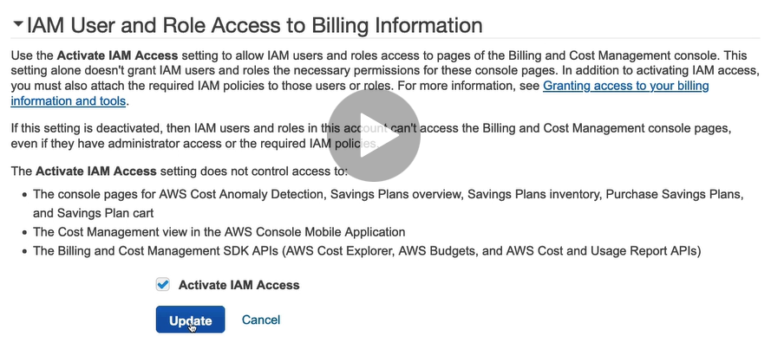

Budget

Budget Types

1. Cost Budget
2. Usage Budget
3. Reservation Budget
4. Saving Plan

Budget can be set based on actual or forecasted value.

## EC2 (Elastic Cloud Compute)

### Introduction

* Elastic Cloud Compute
* Infrastructure as a Service
* Virtual server in the cloud
* Allows you to rent and manage virtual servers in the cloud
* Has elastic compute power: It can grow and shrink based on load in your application
* Are not serverless
* You are able to provision an EC2 instance at the click of a button
* You can also use pre-configured template called AMI (Amazon Machine Image) to launch your resources.
* You will receive 750 compute hours per month on Free Tier Plan. t2.micro is part of AWS free tier.
* You can deploy your applications directly to EC2 instances.
* Amazon EC2 instances can run the Windows, Linux, or MacOS operating systems.
* **Integrated** – EC2 is integrated with most AWS services such as S3, RDS, and VPC to provide a complete, secure solution
* **Secure** – EC2 works in conjunction with VPC to provide a secure location
* **It mainly consists of following capabilities**
  + **Renting virtual server**
  + **Storing data on virtual drives (EBS)**
  + **Distributing incoming traffic (ELB)**
  + **Scaling (ASG)**

EC2 Configuration Options

1. Operating System (OS): Linux, Windows, Mac OS
2. How much compute power and cores (CPU)
3. How much random-access memory (RAM)
4. How much storage space
   1. Network-attached (EBS & EFS)
   2. Hardware (EC2 Instance Store)
5. Network card-speed of the card, public IP address
6. Firewall rules- Security Group
7. Bootstrap Script (configure at first launch)- EC2 User Data

EC2 User Data

1. It is possible to bootstrap our instances using an EC2 User data script.
2. Bootstrapping means launching commands when a machine starts.
3. This script runs only once i.e., when the instance first starts
4. EC2 User data is used to automate boot tasks such as
   1. Installing updates
   2. Installing software
   3. Downloading common files from the Internet
5. EC2 User Data Script runs with the root user

When we create an EC2 Instance, a public IP address and a private IP address is also generated. Next time on stopping same instance and starting it again, new public IP address will be generated while private IP address will still remain same.

EC2 Instance type

1. AWS has the following naming convention:
   1. m5.2xlarge
   2. m=instance class
   3. 5=generation
   4. 2xlarge=size within the instance class
2. General Purpose
   1. Balance between compute, memory and networking
   2. T2.micro is General Purpose EC2 Instance
   3. t..m
3. Compute Optimized
   1. Great for compute-intensive tasks that requires high performance processors
   2. Batch processing
   3. Media transcoding
   4. High performance web servers
   5. High performance computing (HPC)
   6. Scientific modeling and Machine Learning
   7. Dedicated gaming servers
   8. C
4. Memory optimized
   1. Fast performance for workloads that process large data sets in memory
   2. M
5. Storage Optimized
   1. Great for storage intensive tasks that require high sequential read and write access to large data sets on local storage
   2. i…d
6. Accelerated Computing

Security Group

1. Firewall at instance level
2. They control how traffic is allowed into or out of our EC2 instance
3. Contains only allow rules
4. Stateful
5. Security Group rules can reference by IP or by Security Group
6. By default, all inbound traffics is blocked. All outbound traffic is authorized.
7. Can be attached to multiple instances
8. Locked down to a region/ VPC combination. i.e. If we switch to new region or if new VPC is created, we need to create new Security Group
9. Security Group lives outside the EC2- if traffic is blocked the EC2 instance won’t even see it
10. It is good to maintain one separate security group for SSH access
11. If your application is not accessible (time out), then it is a security group issue
12. If your application gives a “connection refused” error, then it is an application error or it is not launched

Classis Ports to know

1. 22 - SSH (Secure Shell)- log into a Linux instance
2. 21 – FTP (File Transfer Protocol)- upload files into a file share
3. 22 - STFP (Secure File Transfer Protocol)-upload files using SSH
4. 80 - HTTP - access unsecured websites
5. 443 - HTTPS - access secured websites
6. 3389 - RDP (Remote Desktop Protocol)- log into a Windows Instance

SSH Summary

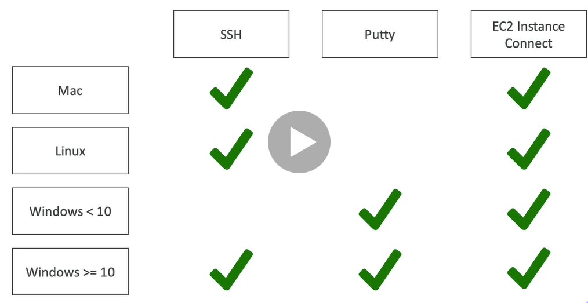

To use EC2 Instance Connect, we need to add inbound rule in Security Group sections for SSH.

### Amazon Machine Image (AMI)

* An Amazon Machine Image (AMI) is a special type of virtual appliance that is used to create a virtual machine within the Amazon Elastic Compute Cloud.
* An AMI includes the following:
  + One or more [**EBS**](https://digitalcloud.training/certification-training/aws-certified-cloud-practitioner/aws-storage/) snapshots, or, for instance-store-backed AMIs, a template for the root volume of the instance
  + Launch permissions that control which AWS accounts can use the AMI to launch instances.
  + A block device mapping that specifies the volumes to attach to the instance when it’s launched.
* AMIs come in three main categories:
  + **Community AMIs** – free to use, generally you just select the operating system you want.
  + **AWS Marketplace AMIs** – pay to use, generally come packaged with additional, licensed software.
  + **My AMIs** – AMIs that you create yourself.

### Metadata and User Data

* User data is data that is supplied by the user at instance launch in the form of a script.
* Instance metadata is data about your instance that you can use to configure or manage the running instance.
* User data is limited to 16KB.
* User data and metadata are not encrypted.
* Instance metadata is available at http://169.254.169.254/latest/meta-data.

### Instance Metadata Query

* The Instance Metadata Query tool allows you to query the instance metadata without having to type out the full URI or category names.

### EC2 in real world

1. Deploy a database

Deploy a database to EC2 gives you full control over the database.

1. Deploy a web application

Deploy web application to multiple availability zones to make web application highly available.

### Methods to access EC2 instance

1. AWS Management Console
2. Secure Shell (SSH)
3. EC2 Instance Connect (EIC)
4. AWS Systems Manager
5. AWS Management Console

* You are able to configure and manage instances via a web browser.

1. Secure Shell (SSH)

* Allows you to connect to your instance from local laptop using SSH Client and keys
* Puttygen converts .pem(privacy enhanced mail) file to ..ppk (putty private key)

1. EC2 Instance Connect

* Browser based connection
* Allows you to connect to instance without using SSH client and keys and directly using terminal in web browser
* For this, you must grant IAM users permission to push public key to the instance.

1. AWS System Manager

* Allows you to manage EC2 instances via a web browser or CLI

Note

The must common way to connect to Linux EC2 instance is via Secure Shell (SSH)

For this key pair is generated.

A key pair, consists of a private key and a public key, which proves your identity when connecting to an EC2 instance.

When user connects to SSH Client laptop, he uses private key. When he connects to EC2 instance, he uses public key.

### EC2 Pricing Model

1. On demand
2. Spot
3. Reserved Instance
4. Dedicated Hosts
5. Savings Plans
6. On demand

* Fixed price in which you are billed based on instance type used
* You pay for what you use
  + For Linux or Windows: billing per second, after the first minute
  + All other operating systems- billing per hour
* No contract
* Use on-demand instances when
  + You cannot make upfront payment or long-term commitment
  + Your applications have unpredictable workloads that cannot be interrupted
  + Your applications are under-development
  + Your applications will not run for more than a year

1. Spot

* Spot instance lets you take advantage of unused EC2 capacity
* Your request is available only if capacity is available
* Use Spot instance when
  + Your application is not concerned about start and stop time of execution
  + Your workload can be interrupted
  + Useful for workloads that are resilient to failure
  + Not suitable for critical jobs or databases
  + Applications that are only feasible at very low compute prices.
  + Users with an urgent need for a large amount of additional compute capacity.
* You can save upto 90% off on-demand prices
* You pay for spot that is in effect at the beginning of each hour
* If Amazon terminate your instances you do not pay, if you terminate you pay for the hour.
* Define max spot price and get the instance while current spot price<your max
  + If current spot price>your max price you can choose to stop or terminate your instance with a 2 minutes grace period.

1. Reserved Instance

* Allows you to commit to a specific instance type for 1 or 3 years e.g. You want to reserve t2.micro instance type
* Use reserved instance when
  + Applications with steady state or predictable usage
  + Your application has steady state usage and you can commit for 1 or 3 years
  + You can make upfront payment
  + Your application requires capacity reservation
* You can save upto 75% off on-demand prices using Standard Reserved Instance
* You are required to sign a contract of 1 or 3 years
* You can pay all-upfront, partial upfront or no upfront. All upfront for maximum term earns the highest discount
* Standard RI, Convertible RI, Scheduled RI
* Convertible RIs provide up to 54% off on-demand price – provides the capability to change the attributes of the RI as long as the exchange results in the creation of RIs of equal or greater value. We can change instance type in such type of RI.
* Scheduled RIs are available to launch within the time window you reserve. With Scheduled Reserved Instances, you can reserve capacity that is scheduled to recur daily, weekly, or monthly, with a specified start time and duration, for a one-year term.

1. Dedicated Hosts

* Allows you to pay for physical server that is dedicated to running your instances. No other AWS customers is going to have applications running on this server. The server basically belongs to you
* Use dedicated hosts when
  + You want to bring your own server-bound software license from vendors like Microsoft and Oracle
  + You have regulatory or corporate compliance requirements around tenancy model
* You can save upto 70% off on-demand prices
* You can bring your existing per-core, per-socket and per-VM software licenses.
* Available as On-Demand or with Dedicated Host Reservation.
* Each dedicated host can only run one EC2 instance size and type.
* Most expensive option.
* Billing is per host.

1. Dedicated Instance

* Virtualized instances on hardware just for you.
* Also uses physically dedicated EC2 servers.
* Does not provide the additional visibility and controls of dedicated hosts (e.g. how instance are placed on a server).
* Billing is per instance.
* May share hardware with other non-dedicated instances in the same account.
* Available as On-Demand, Reserved Instances, and Spot Instances.
* Cost additional $2 per hour per region.

1. Savings Plan

* You do not commit for specific instance type instead you commit to compute usage (measured per hour) for 1 to 3 years
* Use savings plan when
  + You want to lower your bill across multiple compute services
  + You want flexibility to change compute services, instance types, OS or regions
* You can save upto 72% off on-demand prices
* Savings can be shared across various compute services like EC2, Fargate and lambda

How to terminate Spot Instance?

1. First of all, we will create a spot request where we need to specify
   1. Maximum price
   2. Desired number of instances
   3. Launch Specification
   4. Request type-One time/Persistent
   5. Valid From, Valid Until
2. There are two type of request
   1. One time Request: As soon as instance is launched based on your request, your spot request will go away
   2. Persistent Request: Spot request will remain from valid from to valid until period of time. If somehow instance gets interrupted, spot request will get back into action and it will re-start spot instances for you. If you terminate instance but your spot request is still active, spot request will be smart enough to launch instances.
3. You can only cancel Spot Instances requests that are open, active or disabled
4. Cancelling a Spot Request does not terminate instances. It is our responsibility to terminate instances not AWS responsibility.
5. You must first cancel a Spot Request and then terminate the associated Spot instances.

Spot Fleet

1. Define a way to get a set of spot instances and optionally on-demand instances
2. It will try to meet target capacity with price constraints you define
3. Strategies to allocate Spot Instances
   1. lowestPrice
   2. diversified
   3. capcityOptimized
4. Spot Fleets allow us to automatically request Spot Instances with the lowest price

### EC2 Instance Type

1. General Purpose
2. Compute Optimized
3. Memory Optimized
4. Accelerated Computing
5. Storage Optimized

### Features

1. Elastic Load Balancing
2. EC2 Autoscaling
3. Elastic Load Balancing

* Automatically distributes your incoming traffic across multiple EC2 instances
* Types
  + Classic Load Balancer
  + Application Load Balancer
  + Gateway Load Balancer
  + Network Load Balancer

1. EC2 Autoscaling

* Scale up or scale down based on workload in your application
* Reduces impact of system failure and improves availability of your applications
* You can also use autoscaling with Aurora and DynamoDB

Classic Load Balancer

* All incoming traffics will be equally distributed among number of servers we have

Application load Balancer

* Incoming traffics are distributed based on needs of customers
* It has some level of intelligence.
* It enables content-based routing and allows requests to be routed to different application/server behind single load balance.

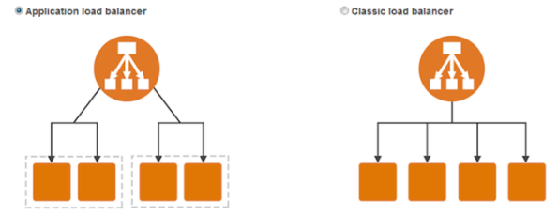

Note

Horizontal Scaling vs Vertical Scaling

Horizontal Scaling (Scaling out)- adds or replaces instances

Vertical Scaling (Scaling up)- upgrades an existing instance

Tag

Allows you to track your instance by adding key/value pair

Eg: We can add a tag to specify “This instance is dedicated for Management purpose.”

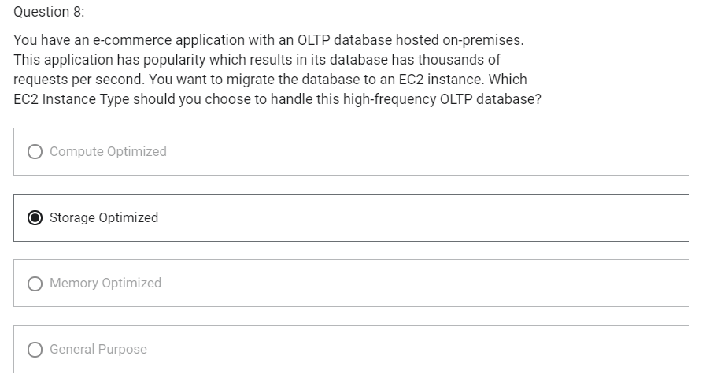

IPv4 vs IPv6 vs Elastic IP

1. Networking has two sorts of IPs:
   1. IPv4
   2. IPv6
2. When you have a public IP, you are accessible over the Internet.
3. When you have a private IP, you are only accessible within your private network.
4. Public IP
   1. Public IP means the machine can be identified on the Internet (www)
   2. Must be unique across the whole web (no two machines can have same public IP)
   3. Can be geo-located easily
5. Private IP
   1. Private IP means the machine can only be identified on a private network only
   2. The IP must be unique across the private network
   3. But two different private networks (two companies) can have same Ips.
   4. Machines connect to Internet using an Internet Gateway
   5. Only a specified range of IPs can be used as private IP
6. Elastic IP
   1. When you stop and then start an EC2 instance, it can changes its public IP
   2. If you need to have a fixed public IP for your instance, you need an Elastic IP
   3. An Elastic IP is a public IPv4 you own as long as you don’t delete it
   4. You can attach it to one instance at a time
   5. With Elastic IP address, you can mask the failure of an instance by rapidly remapping the address to another instance
   6. You can only have 5 Elastic IP in your account (you can ask AWS to increase that)
   7. After we create an Elastic IP, we will be charged for it until it is associated with some other instance. So, quickly associate Elastic IP with instance.

Placement Groups

1. Sometimes you want control over how EC2 Instances are placed (EC2 Instance placement strategy)
2. When you create a placement group, you specify one of the following strategies for the group
   1. Cluster- clusters instances into a low-latency group in a single AZ
   2. Spread- spreads instances across underlying hardware (max 7 instances per group per AZ)- critical applications
   3. Partition- spreads instances across many different partitions (which rely on different sets of racks) within an AZ
3. We can add instance to existing placement group or to a new placement group at the time of creating EC2 instance and configuring instance details.

Placement Groups-Cluster

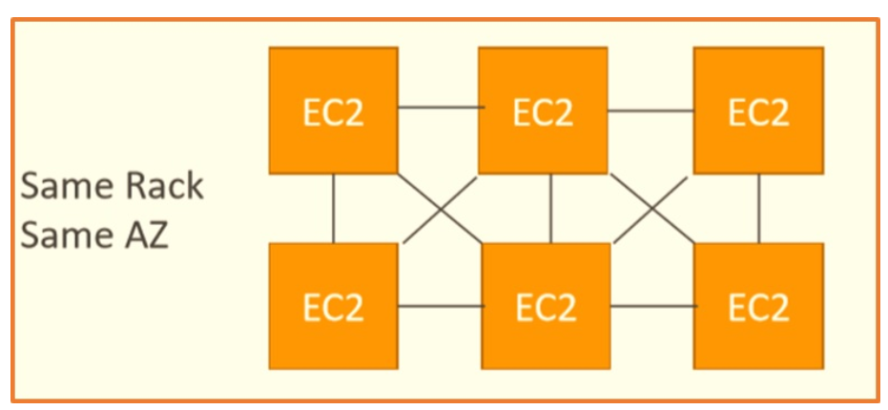

1. All instances are in same rack (same hardware) and same AZ
2. Pros
   1. High network throughput (10 Gbps bandwidth between instances)
   2. Low latency
3. Cons
   1. If the rack fails, all instances fail at the same time
4. Use case
   1. Big Data job that needs to complete fast
   2. Application that needs extremely low latency and high network throughput

Placement Groups- Spread

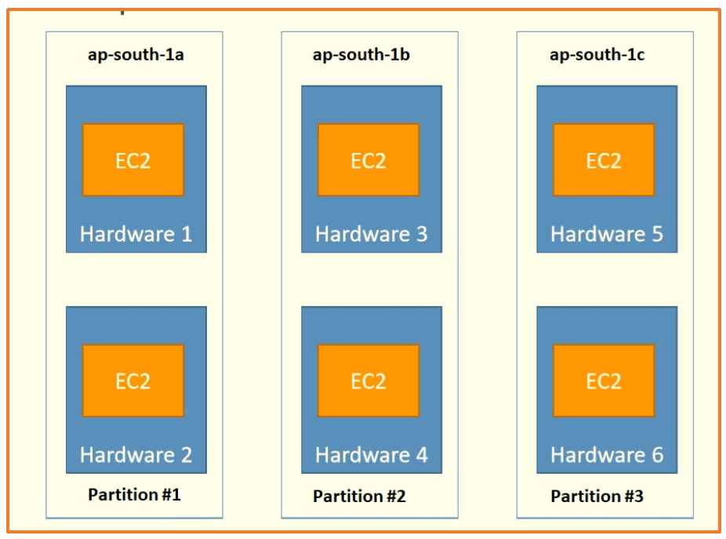

1. All the instances are on different physical hardware
2. Instances are in different hardware in different AZ
3. Pros
   1. Can span across Availability Zones (AZ)
   2. Reduced risk of simultaneous failure
4. Cons
   1. Limited to 7 instances per AZ per placement group
5. Use case
   1. Application that needs to maximize high availability
   2. Critical Applications where each instance must be isolated from failure from each other

Placement Groups- Partition

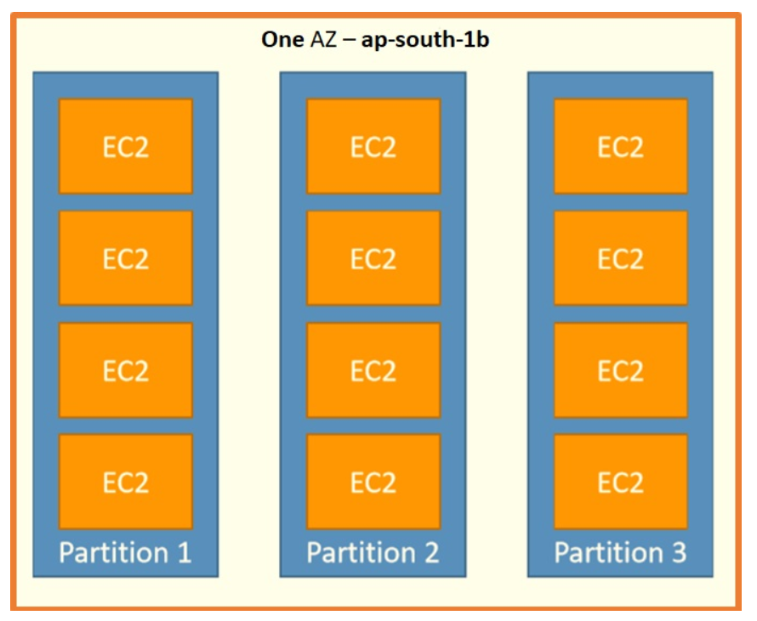

1. Within one AZ , span  multiple partitions, and what is partition, an isolation created by AWS in their data centers which is a physical boundary and ensures one partition's availability does not affects others.
2. Pros
   1. Can span across multiple AZs in the same region
   2. Upto 100s of EC2 instances
   3. Instances in a partition do not share racks with the instances in the other partitions
   4. A partition failure can affect many EC2 but won’t affect other partitions
   5. EC2 instances get access to partition information as metadata
3. Cons
   1. Upto 7 partitions per AZ
4. Use case
   1. HDFS
   2. HBase
   3. Cassandra
   4. Kafka

Elastic Network Interface (ENI)

1. Logical component in a VPC that represents a virtual network card
2. The ENI can have following attributes
   1. Primary private IPv4, one or more secondary IPv4
   2. One Elastic IP (IPv4) per private IPv4
   3. One public IPv4
   4. One or more Security Groups
   5. A MAC address
3. You can create ENI independently and attach them on the fly on EC2 instances for failover
4. Bound to a specific AZ
5. ENI that is created at the time of instance creation will get terminated on termination of corresponding instance
6. ENI that is created independently will remain even when instance gets terminated

EC2 Hibernate

1. We know we can stop, terminate instances
   1. Stop: data on disk (EBS) remains intact in the next step
   2. Terminate: EBS volume (root) gets terminated on termination of instance
2. On start, the following happens
   1. First start: OS boots and the EC2 User Data script is run
   2. Following starts: the OS boots up
   3. Then your application starts, caches get warmed up and that can take time
3. EC2 Hibernate
   1. The in-memory (RAM) state is preserved
   2. Instance boot is much faster
   3. Under the hood: the RAM state is written to a file in the root EBS volume
   4. The root EBS volume must be encrypted
4. Use cases
   1. Long-running processing
   2. Saving the RAM state
   3. Services that take time to initialize
5. Supported instance families- C3, C4, C5, M3, M4, M5, R3, R4, R5
6. Instance RAM size- must be less than 150 GB
7. Instance size- not supported for bare metal instances
8. AMI- Amazon Linux 2, Linux AMI, Ubuntu and Windows
9. Root Volume: must be large, EBS, encrypted, not Instance Store
10. Available for on-demand and reserved instances
11. An instance cannot be hibernated more than 60 days

EC2 Nitro

1. Underlying Platform for the next generation of EC2 instances
2. New virtualization technology
3. Allows for better performance
   1. Better networking options (enhanced networking, HPC, IPv6)
   2. Higher Speed EBS (Nitro is necessary for 64,000 EBS IOPS-max 32,000 on non-Nitro)

EC2- vCPU

1. Multiple threads can run on one CPU (multithreading)
2. Each thread is represented as a virtual CPU (vCPU)

EC2- Optimizing CPU options

1. EC2 instances come with combination of RAM and vCPU
2. In some cases, you may want to change the vCPU options:
   1. # of CPU cores- you can decrease it, helpful if you need high RAM and low number of CPU
   2. # of threads per core- disable multithreading to have 1 thread per CPU, helpful for high performance computing (HPC) workloads
3. Specified during instance launch

EC2- Capacity reservation

1. Capacity Reservations ensure you have EC2 capacity when needed
2. No need for 1 or 3 year commitment
3. Capacity access is immediate, you get billed as soon as it starts
4. Specify
   1. AZ in which to reserve capacity (only one)
   2. Number of instances for which to reserve capacity
   3. Instance attributes including the instance type, tenancy and platform/OS

## EBS (Elastic Block Storage)

### Introduction

* Block storage service
* Like physical hard drive, network drive
* Accessible to a single EC2 instance at a time
* EBS instances can be either General Purpose SSD or Provisioned IOPs SSD
* Data persists even when instance is not running
* Recommended for
  + Quickly accessible data
  + Long-term data storage
  + Running a database on an instance
* EBS volume data persists independently of the life of the instance.
* EBS volumes do not need to be attached to an instance.
* You can attach multiple EBS volumes to an instance.
* You cannot attach an EBS volume to multiple instances (use Elastic File Store instead).
* EBS volumes must be in the same AZ as the instances they are attached to. EBS Volumes are bound to a specific AZ.
* Termination protection is turned off by default and must be manually enabled (keeps the volume/data when the instance is terminated).
* Root EBS volumes are deleted on termination by default.
* Extra non-boot volumes are not deleted on termination by default.
* The behavior can be changed by altering the “DeleteOnTermination” attribute.
* Free Tier: 30 GB of free EBS storage of type General Purpose SSD per month.
* Have a provisioned capacity (size in GBs and IOPS)
  + You get billed for all provisioned capacity
  + You can increase the capacity of the drive over time
* To migrate an EBS volume across AZ
  + Take a snapshot
  + Restore snapshot to another AZ

## EBS Snapshot

* Make a backup (snapshot) of your EBS volume at a point in time
* Not necessary to detach volume to do snapshot, but recommended
* Can copy snapshots across AZ or Region
* Snapshots are stored on S3
* Snapshot can be used to create AMI
* Does not provide granular backup (not a replacement for backup software).
* If you make periodic snapshots of a volume, the snapshots are incremental, which means that only the blocks on the device that have changed after your last snapshot are saved in the new snapshot.
* Even though snapshots are saved incrementally, the snapshot deletion process is designed so that you need to retain only the most recent snapshot in order to restore the volume.
* Snapshots can only be accessed through the EC2 APIs.
* EBS volumes are AZ specific but snapshots are region specific.

### Amazon Machine Image (AMI)

* An Amazon Machine Image (AMI) is a special type of virtual appliance that is used to create a virtual machine within the Amazon Elastic Compute Cloud.
* AMI are a customization of an EC2 instance
* AMI are built for a specific region (and can be copied across regions)
* When we build an AMI, this will also create EBS Snapshots
* An AMI includes the following:
  + One or more [**EBS**](https://digitalcloud.training/certification-training/aws-certified-cloud-practitioner/aws-storage/) snapshots, or, for instance-store-backed AMIs, a template for the root volume of the instance
  + Launch permissions that control which AWS accounts can use the AMI to launch instances.
  + A block device mapping that specifies the volumes to attach to the instance when it’s launched.
* AMIs come in three main categories:
  + **Community AMIs** – free to use, generally you just select the operating system you want.
  + **AWS Marketplace AMIs** – pay to use, generally come packaged with additional, licensed software.
  + **My AMIs** – AMIs that you create yourself.

## EC2 Instance Store

Introduction

* EBS volumes are network drives. If you need high performance hardware disk, use EC2 Instance Store
* Local storage that is physically attached to host computer and cannot be removed
* Storage is temporary as data loss occurs when EC2 instance is stopped
* Are ephemeral or temporary
* Recommended for
  + Temporary storage need
  + Faster with higher I/O speed
  + Good for buffer/cache/scratch data/temporary content
* Instance store volumes cannot be detached/reattached.

EBS Volume Types

1. EBS Volumes come in 6 types
   1. Gp2/gp3 (SSD)-> General Purpose SSD
      1. General purpose SSD volume that balances price and performance for a wide variety of workloads
   2. Io1/io2 (SSD)-> Provisioned IOPS SSD
      1. Highest performance SSD volume for mission-critical low-latency or high-throughout workloads
      2. Critical business applications with sustained IOPS performance
      3. Great for databases workloads
   3. St1 (HDD)-> Throughput Optimized HDD
      1. Low cost HDD volume designed for frequently accessed, throughput-intensive workloads
      2. Big Data, Data Warehouse, Log Processing
      3. Cannot be boot volume
   4. Sc1 (HDD)-> Cold HDD
      1. Lowest cost HDD volume designed for less frequently accessed workloads
      2. Cannot be boot volume
2. EBS Volumes are characterized in Size | Throughout | IOPs
3. Only gp2/gp3 and io1/io2 can be used as boot volumes
4. Gp2: IO increases if the disk size increases
5. Io1: can increase IO independently

EBS Multi-Attach- io1/io2 family

1. Io1/io2 family
2. Attach same EBS volume to multiple EC2 instances in the same AZ
3. Each instance has full read and write permissions to the volume
4. Use case
   1. Achieve higher application availability in clustered Linux applications (ex: Teradata)
   2. Applications must manage concurrent write operations
5. Suppose, we have io2 volume with Multi-Attach, then we can attach multiple instances in same AZ into this volume

EBS Encryption

1. When you create an encrypted EBS volume, you get the following
   1. Data at rest is encrypted inside the volume
   2. All the data in flight moving between instance and volume is encrypted
   3. All snapshots are encrypted
2. Encryption and decryption are handled transparently (you have nothing to do)
3. Encryption has minimal impact on latency
4. EBS Encryption leverages keys from KMS (AES-256)

Encryption: encrypt an unencrypted EBS volume

1. Create an EBS snapshot of volume (Snapshot of unencrypted EBS volume is also unencrypted)
2. Encrypt the EBS snapshot (using copy)
3. Create new EBS volume from snapshot (the volume will also be encrypted)
4. Now you can attach the encrypted volume to the original instance

## Amazon Elastic File System (EFS)

Introduction

* Hierarchical structure
* EFS works with EC2 instances in multi-AZ
* Can be mounted by multiple EC2 instances can be mounted in EC2 or on-premises servers
* Can connect to instance in another VPC
* Can concurrently connect 1 to 1000s of EC2 instances, from multiple AZs.
* Uses NFSv4.1 protocol
* Only supports the Linux file system
* More expensive than EBS
* By default you can create up to 10 file systems per account.
* Use Security group to control access to EFS
* There are two performance modes:
  + Performance Mode
    - “General Purpose” performance mode (default)-> latency sensitive use cases
    - “Max I/O” performance mode-> higher latency, throughput, highly parallel (big data, media processing)
  + Throughput mode
    - Bursting (1 TB= 50 MiB/s + burst of up to 100MiB/s)
    - Provisioned (set your throughput regardless of storage size e.g. 1GiB/s for 1 TB storage)
* Storage Tiers
  + Lifecycle management feature
  + Move file after N days
  + Standard- for frequently accessed files
  + Infrequent access (EFS-IA): lower price to store, cost to retrieve files

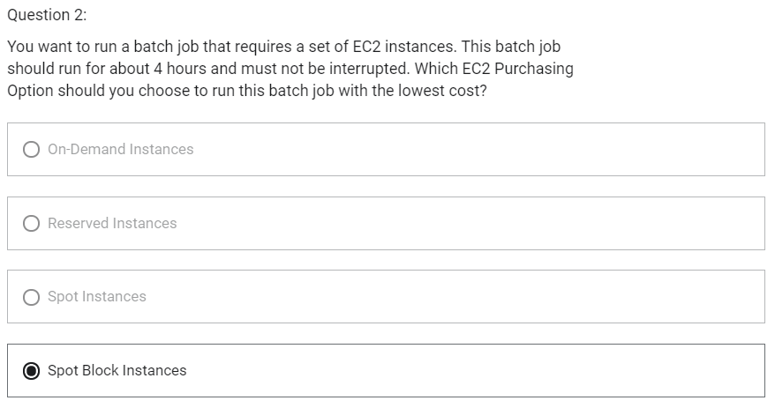

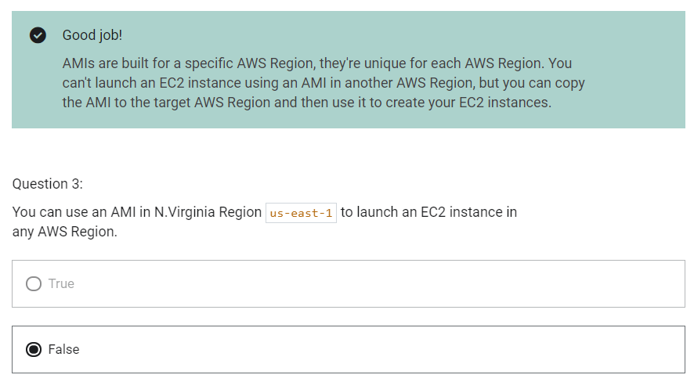

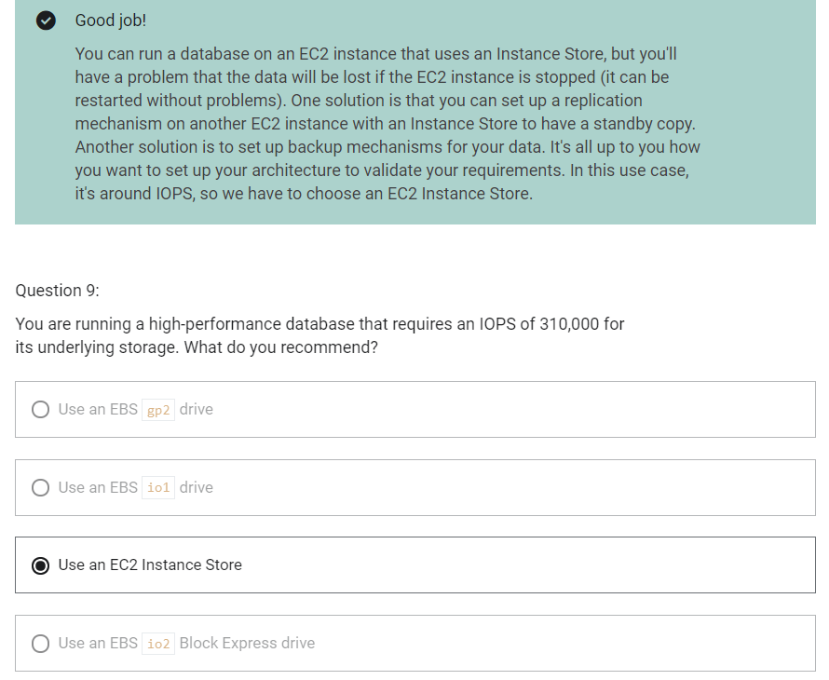

High availability and Scalability

Scalability

1. Scalability means that an application/system can handle greater loads by adapting
2. There are two kinds of scalability
   1. Vertical Scalability
   2. Horizontal Scalability (=elasticity)
3. Vertical Scalability
   1. Increasing the size of the instance
   2. Scale up/down
   3. T1.micro-> t2.large
   4. Common for non-distributed systems such as a database
   5. RDS, ElastiCache are services that can scale vertically
   6. There is usually a limit to how much you can vertically scale
4. Horizontal Scalability
   1. Increasing the number of instances/ systems for your application
   2. Scale out/in
      1. Scale out- add new instance
      2. Scale in- remove existing instance
   3. Common for distributed systems

High Availability

1. High availability means running your application/ system in at least 2 AZ
2. Goal of high AZ is to survive a data center loss

Load Balancing

1. Distribute incoming traffic to multiple downstream instances

Elastic Load Balancer

1. Managed load balancer
2. It is integrated with many AWS services
   1. EC1, EC2 Auto Scaling Groups, Amazon ECS
   2. AWS Certificate Manager (ACM), CloudWatch
   3. Route 53, AWS WAF, AWS Global Accelerator

Health Check

1. Health checks are crucial for load balancers
2. They enable load balancer to know if instances it forwards traffic to are available to reply to requests
3. The health check is done on a port and a route (/health is common)
4. If the response is not 200 (ok), then the instance is unhealthy

Types of Load balancer

1. Classic Load Balancer
   1. Layer 4 (TCP)
   2. Layer 7 (HTTP, HTTPS)
2. Application Load Balancer
   1. Layer 7 (HTTP, HTTPS)
   2. Operates at Application Layer
   3. Load balancing to multiple HTTP applications across machines (target groups)
   4. Load balancing to multiple applications on the same machine
   5. Support for HTTP/2 and WebSocket
   6. Support redirects (from HTTP to HTTPs for example)
   7. Routing tables to different target groups
      1. Routing based on path in URL (example.com/users and example.com/posts)
      2. Routing based on hostname in URL (one.example.com and other.example.com)
      3. Routing based on Query String, Headers (example.com/users?id=123&order=false)
   8. ALB can route to multiple target groups which can be
      1. EC2 instances
      2. ECS tasks
      3. Lambda functions
      4. IP addresses- must be private IP
   9. Fixed hostname (XXX.region.elb.amazonaws.com)
   10. The application servers do not see the IP of the client directly
       1. The true IP of the client is inserted in the header X-Forwarded-For
       2. We can also get Port (X-Forwarded-port) and proto (X-Forwarded-Proto)
3. Network Load Balancer
   1. Layer 4 (TCP, UDP)
   2. Operates at Transport Layer
   3. Handles millions of requests per seconds
   4. Less latency-> 100 ms (vs 400 ms for ALB)
   5. NLB has one static IP per AZ, and supports assigning Elastic IP
   6. NLB are used for extreme performance, TCP or UDP traffic
   7. Not included in the AWS free tier
   8. Target Groups
      1. EC2 instances
      2. IP Addresses- must be private IPs
      3. Application Load Balancer
4. Gateway Load Balancer
   1. Layer 3 – IP packets
   2. Operates at Network Layer
   3. Deploy, scale and manage a fleet of 3rd party network virtual appliances in AWS
   4. Example: Firewalls, Intrusion Detection and Prevention Systems, Deep Packet Inspection Systems, Payload Manipulation
   5. Combines the following functions
      1. Transparent Network Gateway- single entry/exit for all traffic
      2. Load Balancer- distributes traffic to your virtual appliances
   6. Uses GENEVE protocol on port 6081
   7. Target Groups
      1. EC2 instances
      2. IP Addresses- must be private IPs

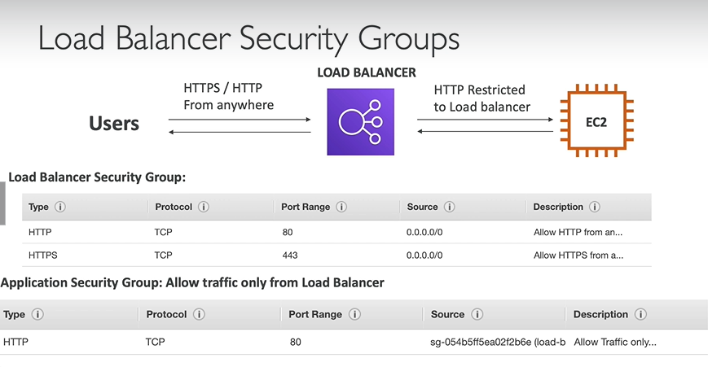

Sticky Sessions (Session Affinity)

1. It is possible to implement stickiness so that the same client is always redirected to same instance behind a load balancer
2. This works for Classic Load Balancers and Application Load Balancers
3. The “cookie: used for stickiness has an expiration date you control
4. Use case
   1. Make sure the user does not lose his session data
5. Enabling stickiness may bring imbalance to the load over the backend EC2 instances

Sticky Sessions- Cookie Names

1. Application-based Cookies
   1. Custom cookie
      1. Generated by the target
      2. Can include any custom attributes required by the application
      3. Cookie name must be specified for each target group
      4. Don’t use AWSALB, AWSALBAPP, AWSALBTG (reserved for use by the ELB)
   2. Application Cookie
      1. Generated by load balancer
      2. Cookie name is AWSALBAPP
2. Duration-based Cookies
   1. Cookie generated by the load balancer
   2. Cookie name is AWSALB for ALB, AWSELB for CLB

Cross Zone Load Balancing

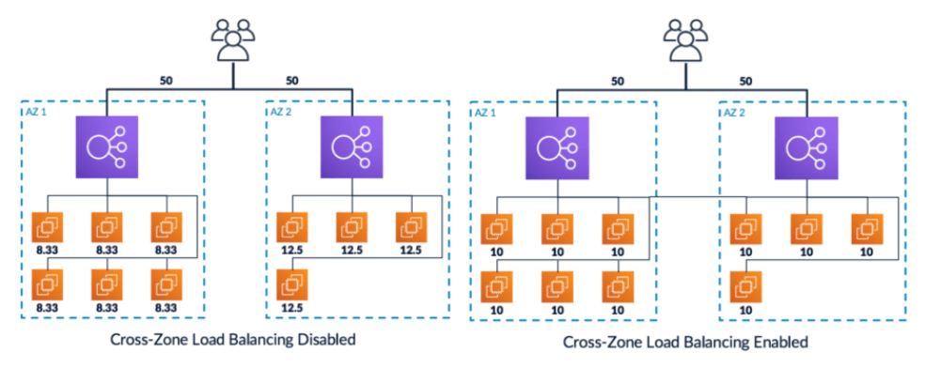

1. With Classic Zone Load Balancing
   1. Each load balancer instance distributes evenly across all registered instances in all AZ
2. Without Classic Zone Load Balancing
   1. Requests are distributed in the instances of the node of the Elastic Load Balancer

Cross-Zone Load Balancing

1. Application Load Balancer
   1. Always on (cannot be disabled)
   2. No charges for inter AZ data
2. Network Load Balancer
   1. Disabled by default
   2. You pay charges ($) for inter AZ data if enabled
3. Classic Load Balancer
   1. Disabled by default
   2. No charges for inter AZ data if enabled

SSL/TLS

1. SSL Certificate allows traffic between your clients and your load balancer to be encrypted in transit (in-flight encryption)
2. SSL refers to Secure Sockets Layer used to encrypt connections
3. TLS refers to Transport Layer Security, which is newer version
4. Public SSL certificates are issued by Certificate Authorities (CA)
5. SSL Certificates have an expiration date and must be renewed regularly

Load Balancer- SSL Certificates

1. The load balancer uses an X.509 certificate (SSL/TLS server certificate)
2. You can manage certificates using ACM (AWS Certificate Manager)
3. You can create/ upload your own certificates alternatively
4. HTTPS listener:
   1. You must specify a default certificate
   2. You can add an optional list of certs to support domains
   3. Clients can use SNI (Server Name Indication) to specify the hostname they reach
   4. Ability to specify a security policy to support older versions of SSL/TLS

SSL- Server Name Indication

1. SNI solves the problem of loading multiple SSL certificates onto one web browser (to serve multiple websites)
2. It is a “newer” protocol and requires the client to indicate the hostname of the target server in the initial SSL handshake
3. The server will then find the correct certificate or return the default one
4. Only works for ALB & NLB, CloudFront
5. Does not work with CLB

Elastic Load Balancers- SSL Certificates

1. Classic Load Balancer
   1. Support only one SSL certificate
   2. Must use multiple CLB for multiple hostname with multiple SSL certificates
2. Application Load Balancer
   1. Supports multiple listeners with multiple SSL certificates
   2. Uses Server Name Indication (SNI) to make it work
3. Network Load Balancer
   1. Supports multiple listeners with multiple SSL certificates
   2. Uses Server Name Indication (SNI) to make it work

Connection Draining

1. Feature naming
   1. For CLB- Connection Draining
   2. For ALB & NLB- Deregistration Delay
2. It will give some time to complete “in-flight requests” while the instance is de-registering or unhealthy
3. It is a **process** that ensures that existing, in-progress requests are given time to complete when the instance is de-registering
4. One the connection is drained, ELB will stop sending new requests to the EC2 instance which is de-registering
5. Between 1 to 3600 seconds (default:300 seconds)
6. Can be disabled (set value to 0)
7. Set to a low value if your requests are short

Auto Scaling Group

1. The goal of Auto Scaling Group (ASG) is to:
   1. Scale out (add EC2 instances) to match an increased load
   2. Scale in (remove EC2 instances) to match a decreased load
   3. Ensure we have a minimum and a maximum number of machines running
   4. Automatically register new instances to a load balancer
2. Number of instances in ASG
   1. Minimum size
   2. Actual Size/ Desired Capacity
   3. Maximum Size
3. ASGs have following attributes
   1. A launch configuration
      1. AMI + Instance Type
      2. EC2 User Data
      3. EBS Volumes
      4. Security Groups
      5. SSH Key Pair
   2. Minimum Size/ Maximum Size/ Initial Capacity
   3. Network + Subnets Information
   4. Load Balancer Information
   5. Scaling Policies

Auto Scaling Alarms

1. It is possible to scale an ASG based on CloudWatch alarms
2. Metrics are computed for overall ASG instance (metrics is calculated as average not min or max)
3. Based on the alarm
   1. We can create scale-out policies (increase the number of instances)
   2. We can create scale-in policies (decrease the number of instances)

Auto Scaling New Rules

1. Target Average CPU Usage
2. Number of requests on the ELB per instance
3. Average Network In
4. Average Network Out

Auto Scaling Custom Metric

1. It is not always compulsory to scale based on metrics provided by AWS. We can create our custom metric like number of connected users

ASG Brain Dump

1. Scaling Policies can be on CPU, Network and can even be on custom metrics or based on a schedule
2. ASGs use launch configurations or Launch Templates
3. To update an ASG, you must provide a new launch configuration/ launch template
4. IAM roles attached to an ASG will get assigned to EC2 instances
5. ASG is free. You pay for the underlying resources being launched
6. Having instances under an ASG means that if they get terminated for whatever reason, the ASG will automatically create new ones as a replacement
7. ASG can terminate instances marked as unhealthy by an LB (and hence replace them)

AutoScaling Policies

1. Dynamic Scaling Policies
   1. Target Tracking Scaling
      1. Most simple and easy to set-up
      2. Example: I want the average ASG CPU to stay at around 40%
   2. Simple/Step Scaling
      1. When a CloudWatch alarm is triggered (CPU>70%), then add 2 units
      2. When a CloudWatch alarm is triggered (CPU<30%), then remove 1
   3. Scheduled Actions
      1. Anticipate a scaling based on known usage patterns
      2. Ex: increase the min capacity to 10 at 5 pm on Fridays
2. Predictive Scaling
   1. Continuously forecast load and schedule scaling ahead

Good Metrics to scale on

1. CPU Utilization
2. RequestCountPerTarget
3. Average Network In/ Out
4. Any Custom Metric

ASG- Scaling Cooldowns

1. The cooldown period is **a configurable setting for your Auto Scaling group** that helps to ensure that it doesn't launch or terminate additional instances before the previous scaling activity takes effect.
2. After a scaling activity happens, you are in the cooldown period (default 300 seconds)
3. During the cooldown period, the ASG will not launch or terminate additional instances (to allow metrics to stabilize)

ASG Default Termination Policy

1. Find the AZ which has the most number of instances
2. If there are multiple instances in the AZ to choose from, delete the one with the oldest launch configuration
3. ASG tries to balance the number of instances across AZ by default

Lifecycle Hooks

1. By default, as soon as an instance is launched in the ASG, it is in service
2. You have the ability to perform extra steps before the instance goes in service (Pending state)
3. You have the ability to perform some actions before the instance is terminated (Terminating state)

Launch Template vs Launch Configuration

1. Both requires ID of AMI, instance type, a key pair, security groups and other parameters that you use to launch EC2 instances (tags, EC2 User Data)
2. Launch Configuration (legacy)
   1. Must be re-created every time
3. Launch Template (newer)
   1. Recommended by AWS going forward
   2. Can have multiple versions
   3. Create parameters subsets (partial configuration for re-use and inheritance)

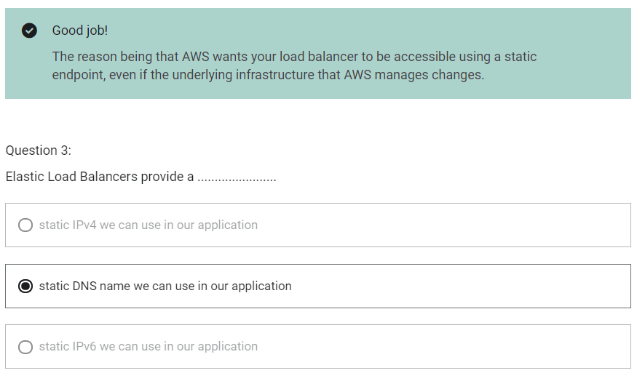

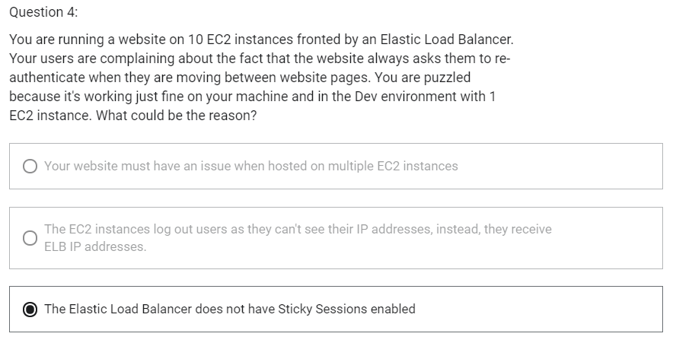

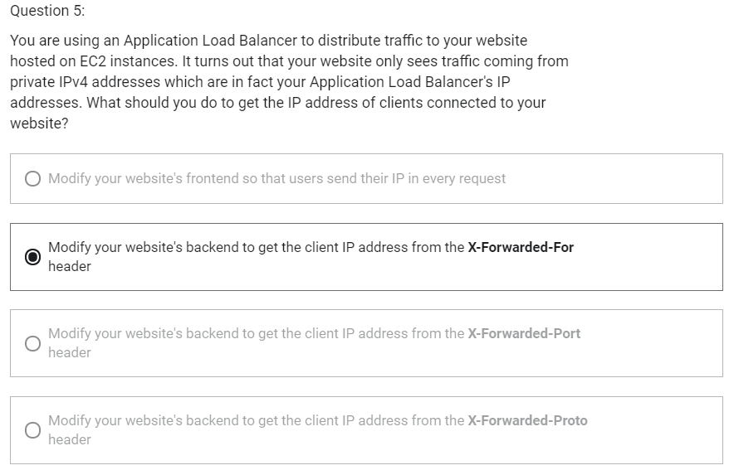

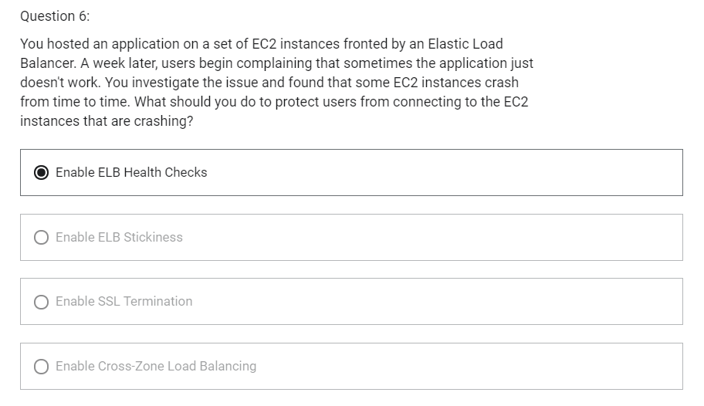

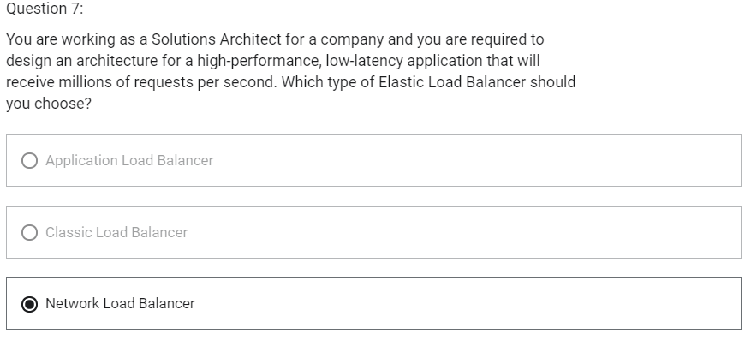

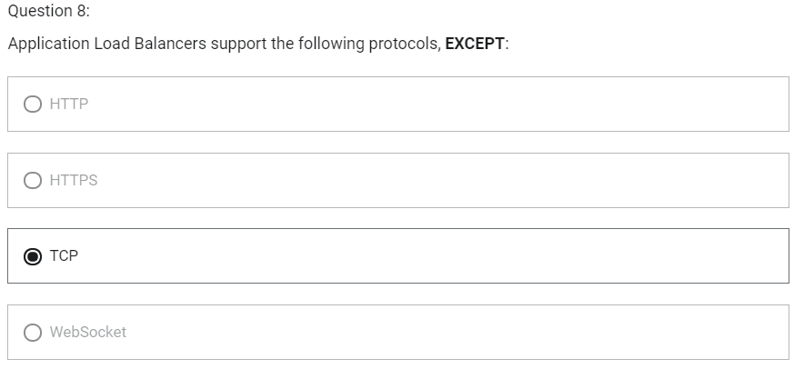

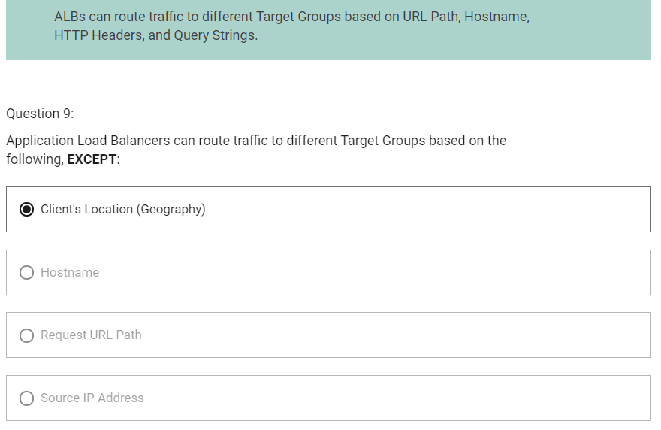

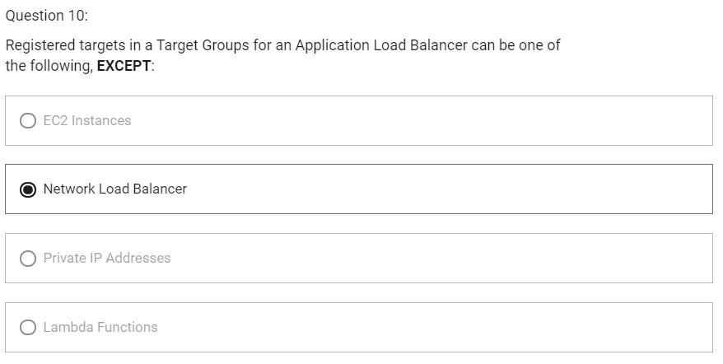

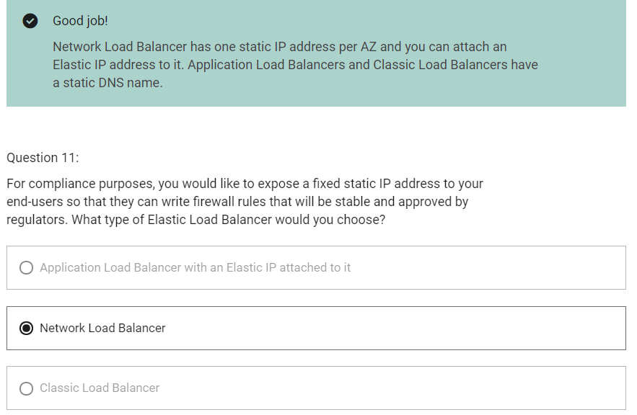

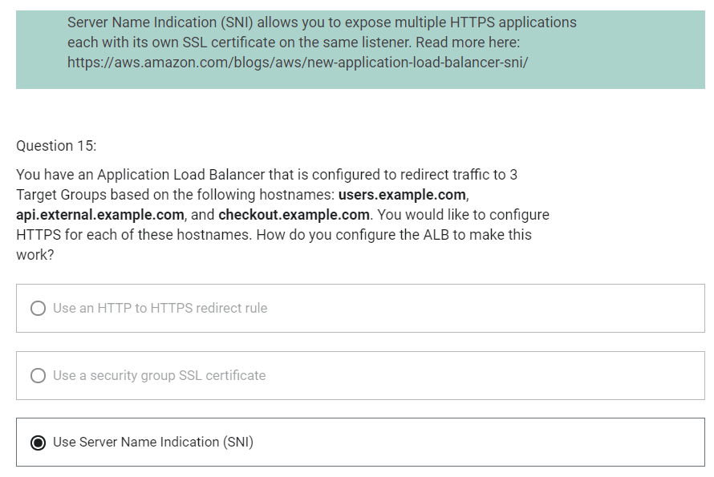

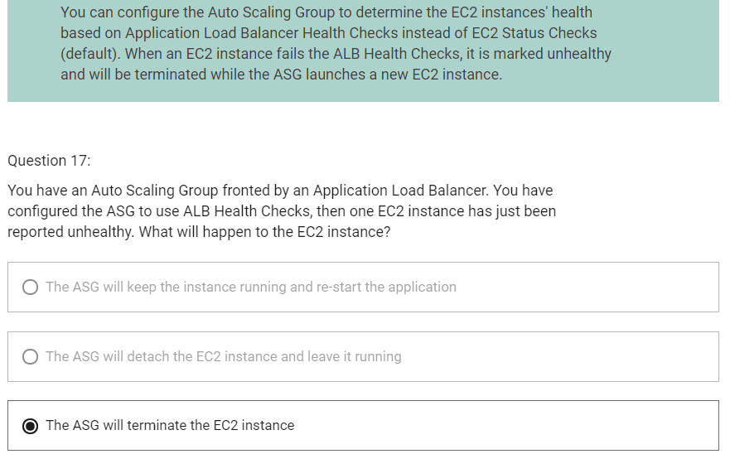

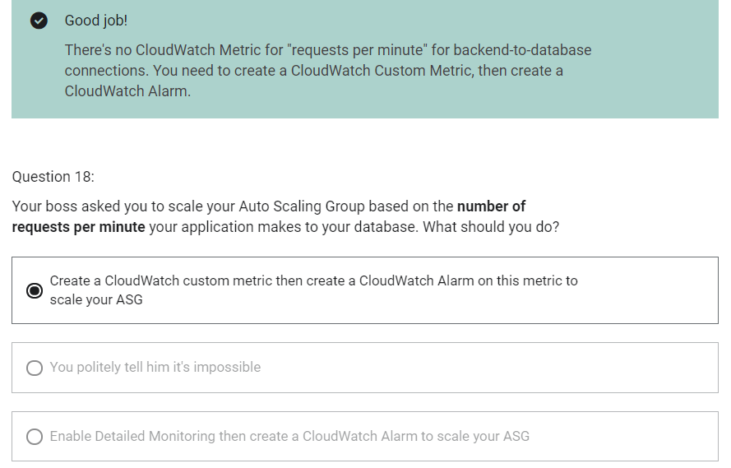

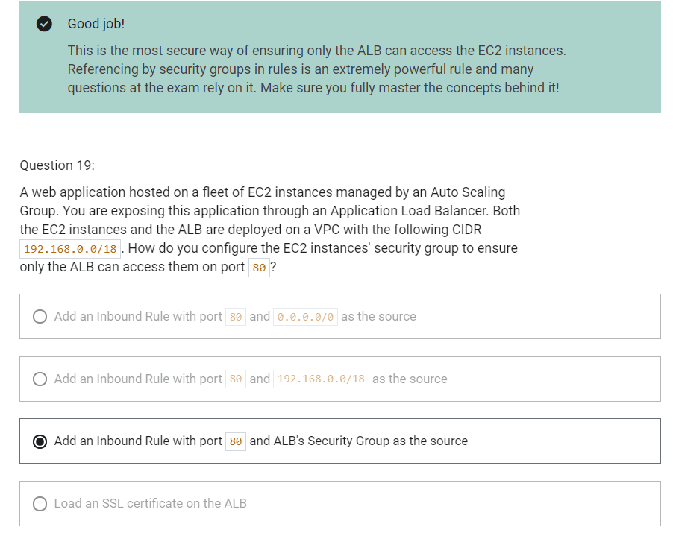

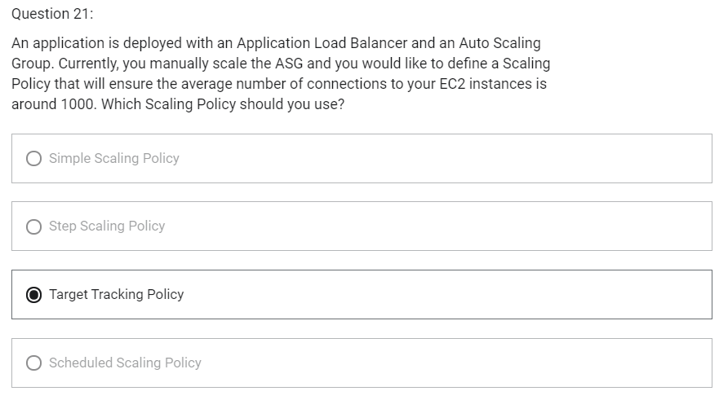

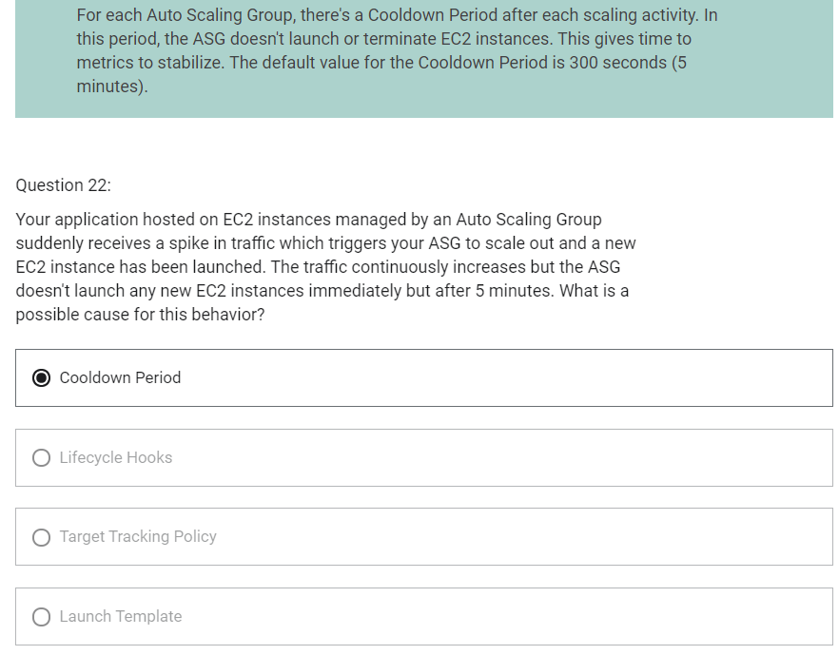

RDS

1. RDS stands for Relational Database Service
2. It is managed database service that use SQL as a query language
3. It allows you to create databases in the cloud that are managed by AWS
   1. Postgres
   2. MySQL
   3. MariaDB
   4. Oracle
   5. Microsoft SQL Server
   6. Aurora (AWS Proprietary database)

Advantages over using RDS versus deploying database on EC2

1. RDS is a managed service
   1. Automated provisioning, OS patching
   2. Continuous backups and restore to specific timestamp (Point in Time Restore)
   3. Monitoring dashboards
   4. Read replicas for improved read performance
   5. Multi-AZ setup for disaster recovery
   6. Maintenance windows for upgrades
   7. Scaling capacity (vertical and horizontal)
   8. Storage backed by EBS (gp2 or io1)
2. BUT You cannot SSH into your instance

RDS Backups

1. Backups are automatically enabled in RDS
2. Automated backups
   1. Daily full backup of database (during the maintenance window)
   2. Transaction logs are backed-up by RDS every 5 minutes
   3. Ability to restore to any point in time (from oldest backup to 5 minutes ago)
   4. 7 days retention (can be increased to 35 days)
3. DB Snapshots
   1. Manually triggered by the user
   2. Retention of backup for as long as you want

RDS- Storage Auto Scaling

1. Helps you increase storage on your RDS database instance dynamically
2. When RDS detects you are running out of free database storage, it scale automatically
3. Avoid manually scaling your database storage
4. You have to set Maximum Storage Threshold (maximum limit for DB storage)
5. Automatically modify storage if
   1. Free storage is less than 10% of allocated storage
   2. Low-storage lasts at least 5 minutes
   3. 6 hours have passed since last modification
6. Useful for applications with unpredictable workloads
7. Supports all RDS database engines(MariaDB, MySQL, PostgreSQL, SQL Server, Oracle)

Read Replicas

1. Up to 5 read replicas
2. Within AZ, Cross AZ or Cross Region
3. Replication is asynchronous, so reads are eventually consistent
4. Read/ Write happens in main database
5. Read happens in read replica. Read replicas are used for SELECT (=read) only kind of statements (not INSERT, UPDATE, DELETE)

RDS Read Replicas- Network Cost

1. In AWS, there is a network cost when data goes from one AZ to another
2. For RDS Read Replicas within the same region, you do not pay that fee
3. In RDS Read Replicas, network cost within same region is free. Network between region is paid.

RDS Multi-AZ (Disaster Recovery)

1. Synchronous replication
2. One DNS Name- automatic app failover to standby
3. Increase availability
4. Failover in case of loss of AZ, loss of network, instance or storage failure
5. No manual intervention in apps
6. Not used for scaling
7. Read Replicas can be setup as Multi AZ for Disaster Recovery
8. No read and write happens in Standby instance

RDS- from Single AZ to Multi AZ

1. Zero downtime operation (no need to stop DB)
2. Just click on “modify” for the database
3. The following happens internally
   1. A snapshot is taken
   2. A new DB is restored from the snapshot in a new AZ
   3. Synchronization is established between the two databases

RDS Security- Encryption

1. At rest encryption
   1. Is done only when you first create the database instance
   2. Possibility to encrypt the master and read replicas with AWS KMS-AES-256 encryption
   3. Encryption has to be defined at launch time
   4. If the master is not encrypted, the read replicas cannot be encrypted
   5. Transparent Data Encryption (TDE) available for Oracle and SQL Server
2. In-flight encryption
   1. SSL certificates to encrypt data to RDS in flight
   2. Provide SSL options with trust certificate when connecting to database
   3. To enforce SSL
      1. PostgreSQL: rds.force_ssl=1 in the AWS RDS Console (Parameter Groups)
      2. MySQL: Within the DB: GRANT USAGE ON *.* TO ‘mysqluser’@’%’ REQUIRE SSL;

RDS Encryption Operations

1. Encrypting RDS backups
   1. Snapshots of unencrypted RDS databases are un-encrypted
   2. Snapshots of encrypted RDS databases are encrypted
   3. Can copy a snapshot into an encrypted one
2. To encrypt an un-encrypted RDS database
   1. Create a snapshot of the unencrypted database
   2. Copy the snapshot and enable encryption for the snapshot
   3. Restore the database from encrypted snapshot
   4. Migrate applications to the new database, and delete the old database

RDS Security- Network and IAM

1. Network Security
   1. RDS Databases are usually deployed within a private subnet, not in a public one
   2. RDS security works by leveraging security groups- it controls which IP/security group can communicate with RDS
2. Access Management
   1. IAM policies help control who can manage AWS RDS (through RDS API)
   2. Traditional username and password can be used to login into the database
   3. IAM based authentication can be used to login into RDS MySQL and PostgreSQL

RDS- IAM Authentication

1. IAM database authentication works with MySQL and PostgreSQL
2. You do not need a password, just an authentication token obtained through IAM and RDS API calls
3. Auth token has a lifetime of 15 minutes

AWS responsibility- No SSH access

Aurora

1. Aurora is a proprietary technology from AWS (not open source)
2. PostgreSQL and MySQL are both supported as Aurora database
3. Is cloud optimized
4. 5x performance improvement over MySQL on RDS
5. 3x performance of Postgres on RDS
6. Aurora storage automatically grows in increments of 10GB, upto 128 TB
7. Aurora can have 15 replicas while MySQL has 5, and the replication process is faster
8. Failover in Aurora is instantaneous
9. Aurora costs more than RDS (20% more)
10. Shared storage volume

Aurora High Availability and Read Scaling

1. 6 copies of your data across AZ
   1. 4 copies out of 6 needed for write
   2. 3 copies out of 6 copies for reads
2. One Aurora instance takes writes (master)
3. Automated failover for master in less than 30 seconds
4. Master + up to 15 Aurora Read Replicas server reads
5. Support for Cross Region Replication

Aurora DB Cluster

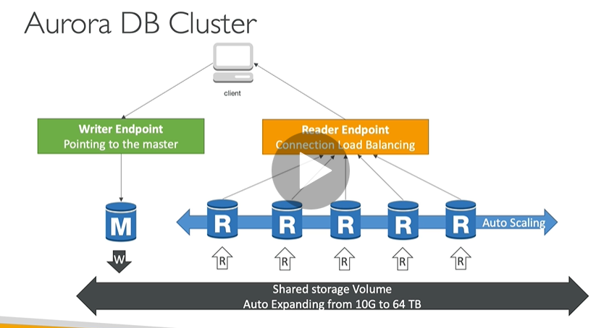

Features of Aurora

1. Automatic fail-over
2. Backup and Recovery
3. Isolation and Security
4. Industry compliance
5. Push-button scaling
6. Automated Patching with Zero Downtime
7. Advanced Monitoring
8. Routine Maintenance
9. Backtrack: restore data at any point of time without using backups

Aurora Security

1. Similar to RDS
2. Encryption at rest using KMS
3. Automated backups, snapshots and replicas are also encrypted
4. Encryption in flight using SSL
5. Possibility to authenticate using IAM token (same method as RDS)
6. You are responsible for protecting the instance with security groups
7. You can not SSH

Aurora Replicas- Auto Scaling

1. It is possible to scale read replicas of Aurora

Aurora- Custom Endpoints

1. Define a subset of Aurora instances as a custom endpoint
2. Example: run analytical queries on specific replicas
3. Reader endpoint is generally not used after defining Custom Endpoints

Aurora Serverless

1. Automated database instantiation and auto-scaling based on actual usage
2. Good for infrequent, intermittent or unpredictable workloads
3. No capacity planning needed
4. Pay per second

Aurora Multi-Master

1. In case you want immediate failover for write node
2. Multiple instances can perform read/write

Global Aurora

1. Aurora Cross Region Read Replicas
   1. Useful for disaster recovery
2. Aurora Global Database (recommended)
   1. 1 primary region (read/write)
   2. Upto 5 secondary (read-only) regions, replication lag is less than 1 second
   3. Upto 16 read replicas per secondary region
   4. Helps for decreasing latency
   5. Promoting another region (for disaster recovery) has an RTO (recovery time of) < 1 minute

Aurora Machine Learning

1. Supported services
   1. Amazon SageMaker
   2. Amazon Comprehend

ElastiCache

1. The same way RDS is to get managed Relational Databases
2. ElastiCache is to get managed Redis or Memcached
3. Caches are in-memory databases with really high performance, low latency
4. Helps reduce load off of databases for read intensive workloads
5. Helps make your application stateless
6. AWS takes care of OS maintenance/ patching optimizations, setup, configurations, monitoring, failover recovery and backups
7. Using ElastiCache involves heavy application code changes

DB Cache

1. Application queries ElastiCache, if not available, get from RDS and store in ElastiCache
2. Helps relieve load in RDS
3. Cache must have an invalidation strategy to make sure only the most current data is used in there

ElastiCache- User Session Store

1. User logs into any of the application
2. The application writes the session data into ElastiCache
3. The user hits another instance of our application
4. The instance retrieves the data and the user is already logged in

ElastiCache- Redis vs Memcached

Redis

1. Multi AZ with Auto-Failover
2. Read Replicas to scale reads and have high availability
3. Data Durability using AOF persistence
4. Backup and restore features

Memcached

1. Multi-node for partitioning of data (sharding)
2. No high availability (replication)
3. Non persistent
4. No backup and restore
5. Multi-threaded architecture

ElastiCache- Cache Security

1. All caches in ElastiCache
   1. Do not support IAM authentication
   2. IAM policies on ElastiCache are only used for AWS API-level security
2. Redis AUTH
   1. You can set a “password/token” when you create a Redis cluster
   2. This is an extra level of security of your cache (on top of security groups)
   3. Support SSL in flight encryption
3. Memcached
   1. Supports SASL-based authentication (advanced)

Patterns for ElastiCache

1. Lazy Loading
   1. All the read data is cached
   2. Data can become stale in cache
2. Write Through
   1. Adds or updates data in cache when written to a DB
   2. No stale data
3. Session Store
   1. Store temporary session data in a cache (using TTL features)

ElastiCache- Redis Use Case

1. Gaming Leaderboards are computationally complex
2. Redis Sorted Sets guarantee both uniqueness and element ordering
3. Each time a new element is added, it is ranked in real tie, then added in correct order

Important Ports

1. FTP - 21
2. SSH - 22
3. SFTP – 22 (same as SSH)
4. HTTP – 80
5. HTTPS – 443

RDS Database Ports

1. PostgreSQL – 5432
2. MySQL – 3306
3. Oracle RDS – 1521
4. MSSQL Server – 1433
5. MariaDB – 3306 (same as MySQL)
6. Aurora – 5432 (if PostgreSQL compatible) or 3305 (if MySQL compatible)

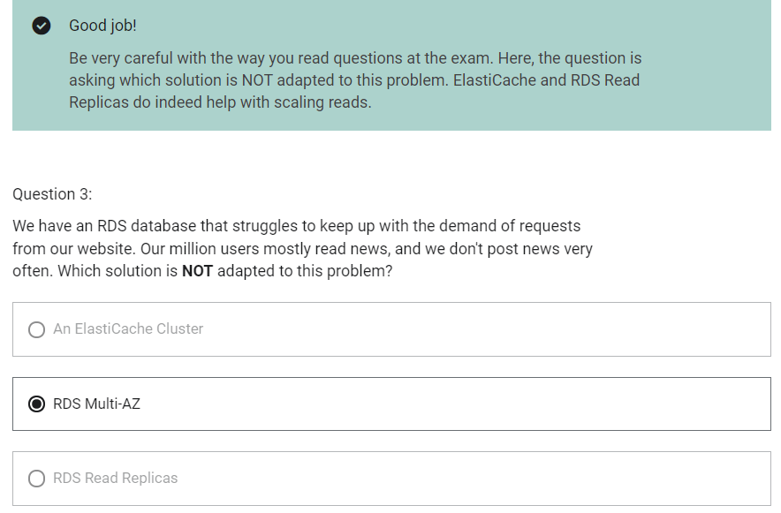

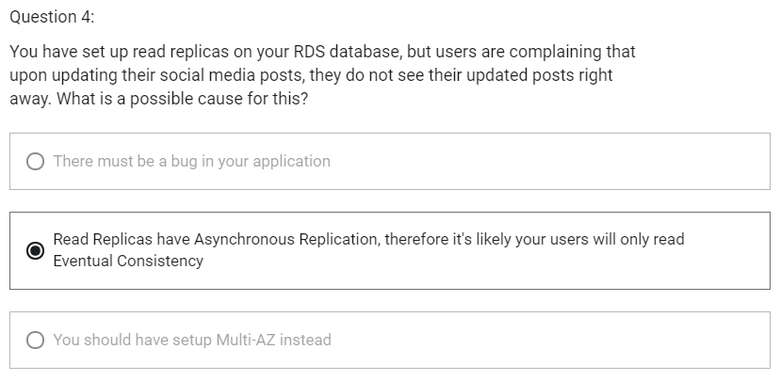

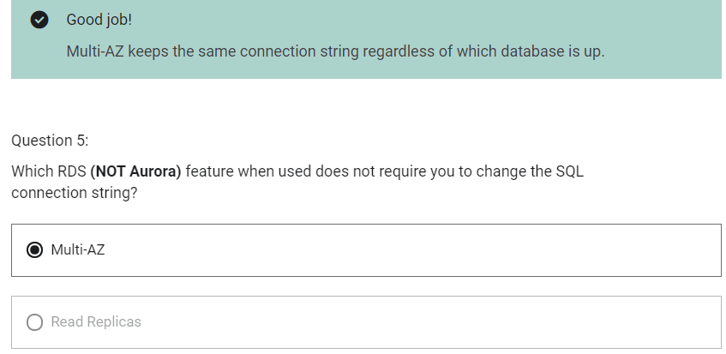

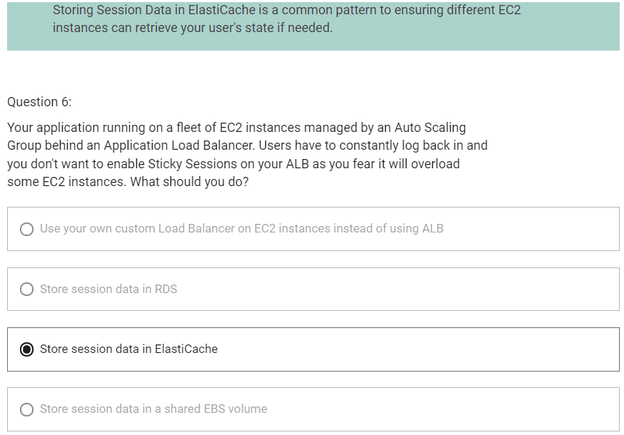

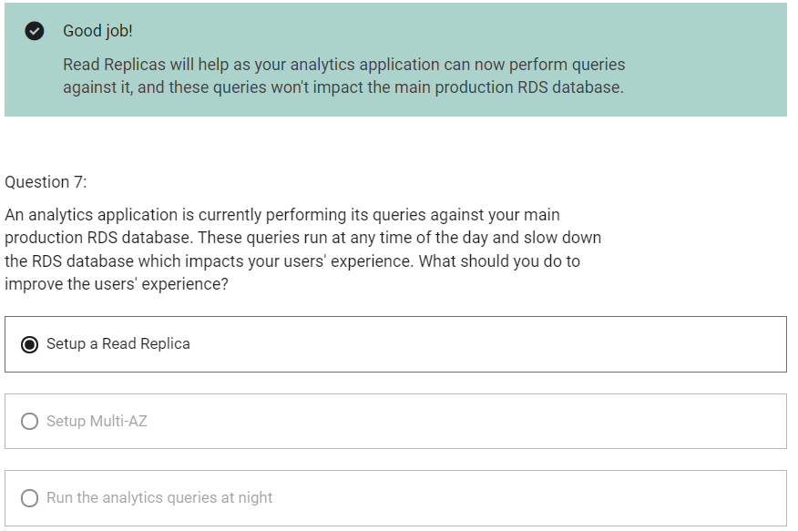

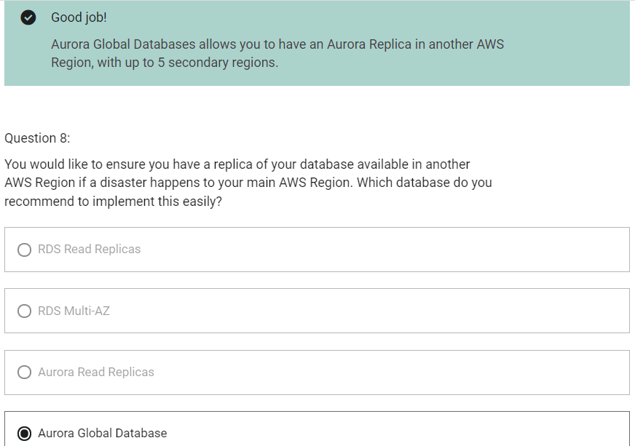

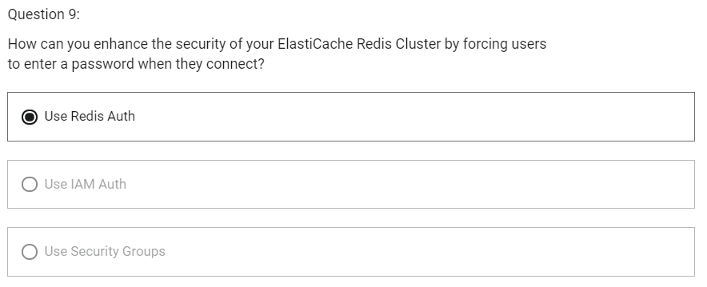

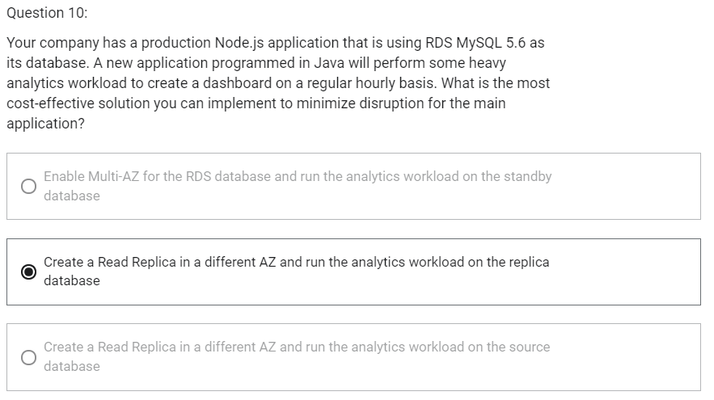

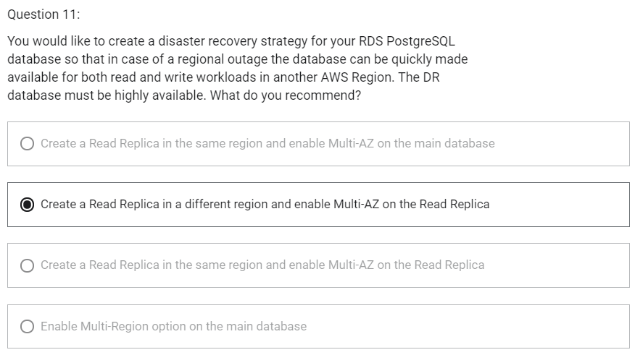

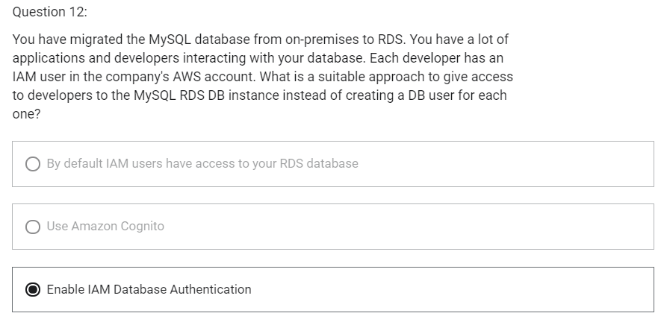

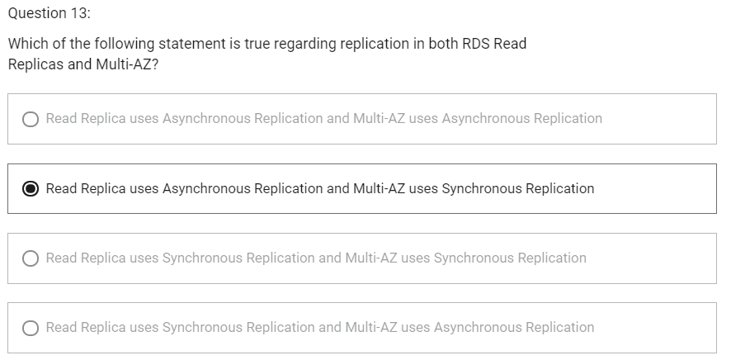

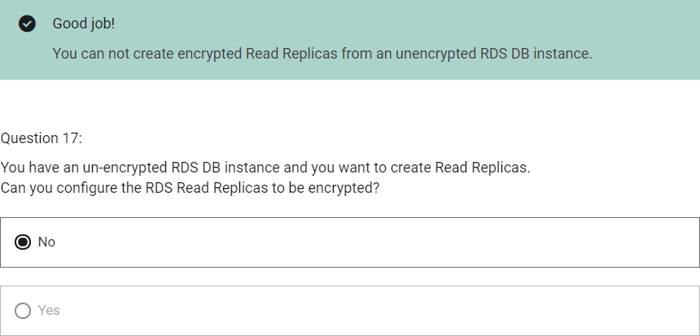

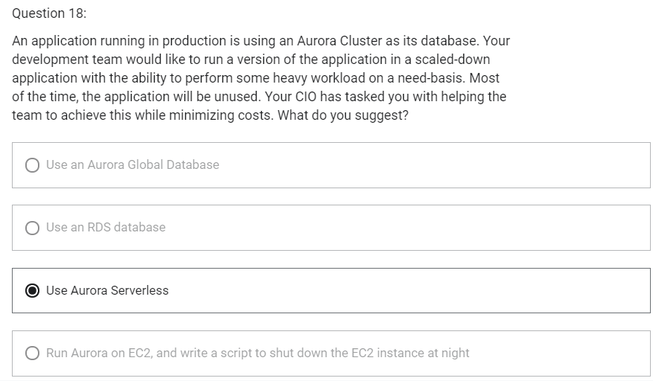

DNS Terminologies

1. Domain Registrar
   1. Amazon Route 53
   2. GoDaddy
2. DNS Records
   1. A
   2. AAAA
   3. CNAME
   4. NS
3. Zone File
   1. Contains DNS records
4. Name Server
   1. Resolves DNS queries
5. Top Level Domain (TLD)
   1. .com
   2. .org
6. Second Level Domain (SLD)
   1. Amazon.com
   2. Google.com

<http://api.www.example.com>

TLD-> .com

SLD-> example.com

Sub Domain-> [www.example.com](http://www.example.com)

Domain Name-> api.www.example.com

http-> Protocol

FQDN (Fully Qualified Domain Name)-> <http://api.www.example.com>

Route 53

1. Highly available, scalable, fully managed and Authoritative DNS
   1. Authoritative-> customer (you) can update the DNS records
2. Route 53 is also a Domain Registrar-> helps in domain name registration
3. Ability to check the health of your resources
4. The only AWS service which provides 100% availability SLA
5. Why Route 53?
   1. 53 is a reference to the traditional DNS port

Route 53- Records

1. How you want to route traffic for a domain
2. Each record contains
   1. Domain/ Subdomain name: example.com
   2. RecordType: A or AAAA
   3. Value: 123.456.789.123
   4. Routing Policy: how route 53 responds to queries
   5. TTL: amount of time the record cached at DNS Resolvers
3. Route 53 supports following DNS record types
   1. A – maps a hostname to IPv4
   2. AAAA – maps a hostname to IPv6
   3. CNAME – maps a hostname to another hostname
      1. The target is a domain name which must have a A or AAAA record
      2. Can not create a CNAME record for the top node of a DNS namespace
      3. Ex: you cannot create for example.com, but you can create for [www.example.com](http://www.example.com)
   4. NS – Name Servers for the Hosted Zone

Route 53 – Hosted Zones

1. A container for records that define how to route traffic to a domain and its subdomain
2. Public Hosted Zones
   1. Allows anyone from Internet to query your record
   2. Contains records that specify how to route traffic on the Internet (public domain names)
3. Private Hosted Zones
   1. Allows querying only from private network like your VPC
   2. Contains records that specify how you route traffic within one or more VPCs (private domain names)
4. You pay $0.5 per month per hosted zone

Route 53-TTL

1. Time to Live
2. Time period for which result of record is cached into client machine
3. High TTL
   1. E.g. 24 hr
   2. Less traffic on route 53
   3. Possibly outdated records
4. Low TTL
   1. E.g. 60 sec
   2. More traffic on Route 53
   3. Records are outdated for less time
   4. Easy to change records
5. Except for Alias records, TTL is mandatory for each DNS record

CNAME vs Alias

CNAME

1. Points a hostname to any other hostname (app.mydomain.com-> blabla.anything.com)
2. Only for non root domain (something.mydomain.com)

Alias

1. Points a hostname to an AWS Resource (app.mydomain.com-> blabla.amazonaws.com)
2. Works for root domain and non root domain (mydomain.com)
3. Free of charge
4. They have native health check capability

Route 53- Alias Records

1. Maps a hostname to an AWS resource
2. An extension to DNS functionality
3. Automatically recognizes changes in the resource’s IP addresses
4. Unlike CNAME, it can be used for the top node of a DNS namespace E.g. example.com
5. Alias record is always of type A/AAAA for AWS resources (IPv4/IPv6)
6. You cannot set TTL. Its set automatically by Route 53

Route 53- Alias Records Targets

1. Elastic Load Balancers
2. CloudFront Distributions
3. API Gateway
4. Elastic Beanstalk environments
5. S3 Websites
6. VPC Interface Endpoints
7. Global Accelerator
8. Route 53 record in the same hosted zone
9. You cannot set an ALIAS record for an EC2 DNS name

Routing Policy

1. Define how Route 53 responds to DNS queries
2. Route 53 supports the following routing policies
   1. Simple
   2. Weighted
   3. Failover
   4. Latency based
   5. Geolocation
   6. Multi-value Answer
   7. Geoproximity

Routing Policy- Simple

1. Route traffic to a single resource
2. Can specify multiple values in the same record
3. If multiple values are returned, a random one is chosen by the client
4. When alias is enabled, specify only one AWS resource
5. Cannot be associated with health checks

Routing Policy- Weighted

1. Control the % of the requests that go to each specific resource
2. Assign each record a relative weight
   1. Traffic (%)= weight for a specific record/ Sum of all the weights for all records
   2. Weights don’t need to sum up to 100
3. DNS records must have the same name and type
4. Can be associated with Health Checks
5. Use cases
   1. Load balancing between regions
   2. Testing new application versions
6. Assign a weight of 0 to a record to stop sending traffic to a resource
7. If all records have weight of 0, then all records will be returned equally

Routing Policy- Latency-based

1. Redirect to the resource that has the least latency close to us
2. Helpful when latency for users is a priority
3. Latency is based on traffic between users and AWS Regions
4. Can be associated with Health Checks (has a failover capability)

Route 53- Health Checks

1. HTTP Health Checks are only for public resources
2. Health check-> Automated DNS failover
   1. Health checks that monitor an endpoint
   2. Health checks that monitor other health checks (calculated health checks)
   3. Health checks that monitor CloudWatch Alarms (helpful for private resources)
3. Health checks are integrated with CloudWatch metrics

Health Checks- Monitor an Endpoint

1. About 15 global health checks will check the endpoint health
   1. Healthy/Unhealthy Threshold- 3 (default)
   2. Interval- 30 sec (can be set to 10 sec- higher cost)
   3. Supported protocol- HTTP, HTTPS and TCP
   4. If >18% of health checkers report the endpoint is healthy, Route 53 considers it Healthy. Otherwise, it is Unhealthy
   5. Ability to choose which locations you want Route 53 to use
2. Health checks pass only when the endpoint responds with 2xx and 3xx status codes
3. Health Checks can be setup to pass/fail based on text in the first 5120 bytes of the response

Route 53- Calculated Health Checks

1. Combine the results of multiple health checks into a single Health Check
2. You can use OR, AND or NOT
3. Can monitor upto 256 child health checks
4. Specify how many of the health checks need to pass to make the parent pass
5. Usage
   1. Perform maintenance to your website without causing all health checks to fail

Health Checks- Private Hosted Zones

1. Route 53 health checkers are outside the VPC
2. They cannot access private endpoints (private VPC or on-premises resource)
3. You can create a CloudWatch Metric and associate a CloudWatch Alarm, then create a Health Check that checks the alarm itself

Routing Policy- Failover

1. Route traffic to healthy instance
2. There will be primary and secondary record. Primary record should be associated with health check
3. Active-Passive

Routing Policy- Geolocation

1. Different from latency-based
2. This routing is based on user location
3. Specify location by continent, country or by US State (if there is overlapping most precise location is selected)
4. Should create a “Default” record (in case there is no match on location)
5. Use case
   1. Website localization
   2. Restrict content distribution
   3. Load balancing
6. Can be associated with Health Checks

Routing Policy- Geoproximity

1. Route traffic to your resources based on geographic location of users and resources
2. Ability to shift more traffic to resources based on the defined bias
3. To change the size of the geographic region, specify bias values
   1. To expand (1 to 99) – more traffic to the resource
   2. To shrink (-1 to -99) – less traffic to the resource
4. Resources can be
   1. AWS resources (specify AWS region)
   2. Non-AWS resources (specify latitude and longitude)
5. You must use Route 53 Traffic Flow (advanced) to use this feature

Route 53- Traffic flow

1. Simplify the process of creating and maintaining records in large and complex configurations
2. Visual editor to manage complex routing decision trees
3. Configurations can be saved as Traffic Flow Policy
   1. Can be applied to different Route 53 Hosted Zones (different domain names)
   2. Supports versioning

Routing Policy- Multi-value

1. Use when routing traffic to multiple resources
2. Route 53 return multiple values/resources
3. Can be associated with Health Checks (return only values for healthy resources
4. Upto 8 healthy records are returned for each Multi-Value query
5. Multi-Value is not a substitute for having an ELB

Domain Registrar vs DNS Service

1. You buy or register your domain name with a Domain Registrar typically by paying annual charges (E.g. GoDaddy, Amazon Registrar Inc,..)
2. Domain Registrar usually provides you with a DNS service to manage your DNS records
3. But you can use another DNS service to manage your DNS records
4. Ex: purchase the domain from GoDaddy and use Route 53 to manage DNS records
5. Domain Registrar!=DNS Service. But every Domain Registrar usually comes with some DNS features

3rd Party Registrar with Amazon Route 53

1. If you buy your domain on a 3rd party registrar, you can still use Route 53 as the DNS Service provider
   1. Create a Hosted Zone in Route 53
   2. Update NS Records on 3rd party website to use Route 53 Name Servers

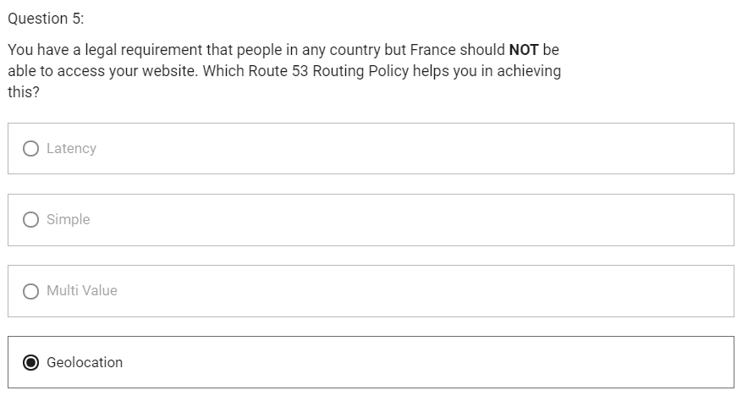

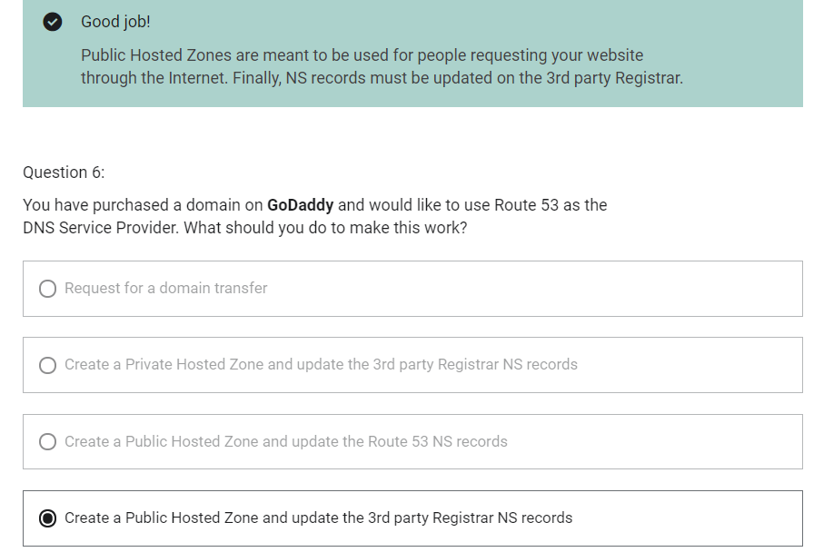

Instantiating Applications quickly

1. EC2 Instances
   1. Use a Golden AMI- Install your applications, OS dependencies, etc.. beforehand and launch your EC2 instance from the Golden AMI
   2. Bootstrap using User Data- For dynamic configuration, use User Data scripts
   3. Hybrid- mix Golden AMI and User Data (Elastic Beanstalk)
2. RDS Databases
   1. Restore from a snapshot- the database will have schemas and data ready
3. EBS Volumes
   1. Restore from a snapshot- the disk will already be formatted and have data

ElasticBeanstalk

1. It is a developer centric view of deploying an application on AWS
2. Managed service
   1. Automatically handles capacity provisioning, load balancing, scaling, application health monitoring, instance configuration, ..
   2. Just the application code is the responsibility of the developer
3. We will still have full control over the configuration
4. Beanstalk is free but you pay for the underlying instances

Elastic Beanstalk- Components

1. Application
2. Application version
3. Environment
   1. Collection of AWS services running an application version
   2. Tiers: Web Server Environment Tier & Worker Environment Tier
   3. You can create multiple environments (dev, test, prod, ..)

Elastic Beanstalk- Supported Platforms

1. Go
2. JavaSE
3. Java with Tomcat
4. .NET Core on Linux
5. .NET on Windows Server
6. Node.js
7. PHP
8. Python
9. Ruby
10. Packer Builder
11. Single Container Docker
12. Multi-container Docker
13. Preconfigured Docker
14. If not supported, you can write your custom platform

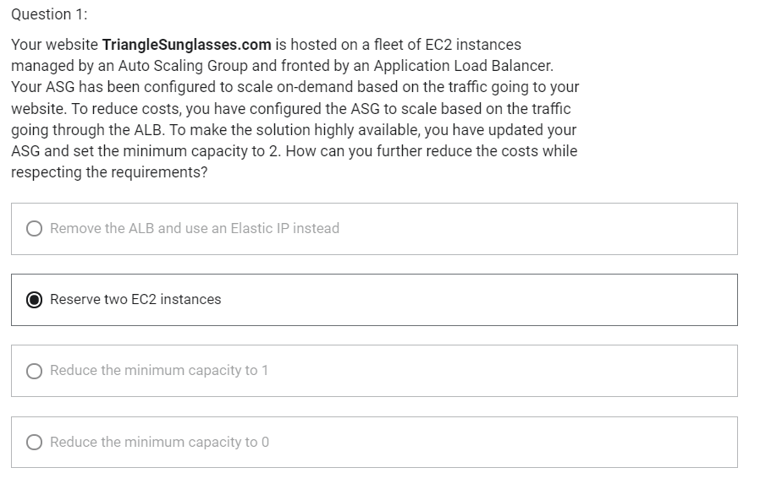

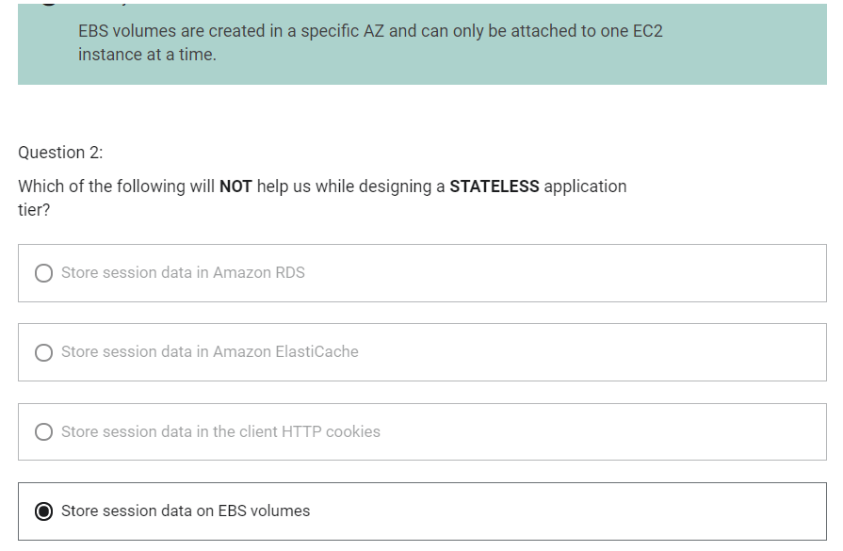

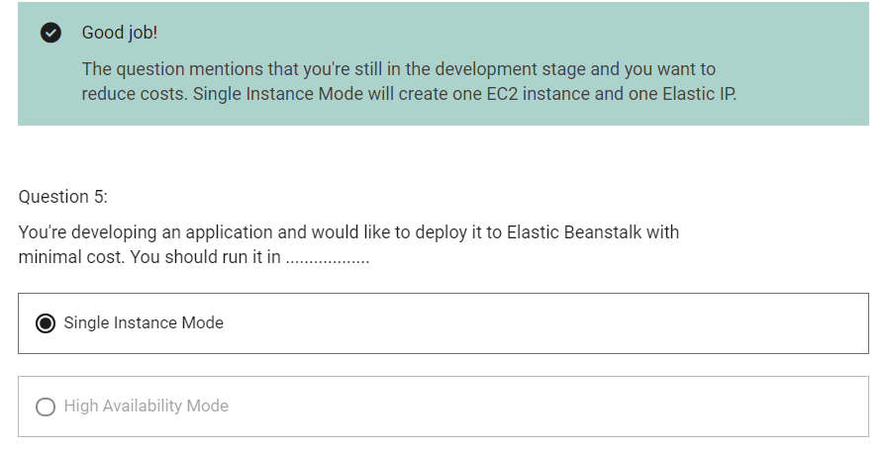

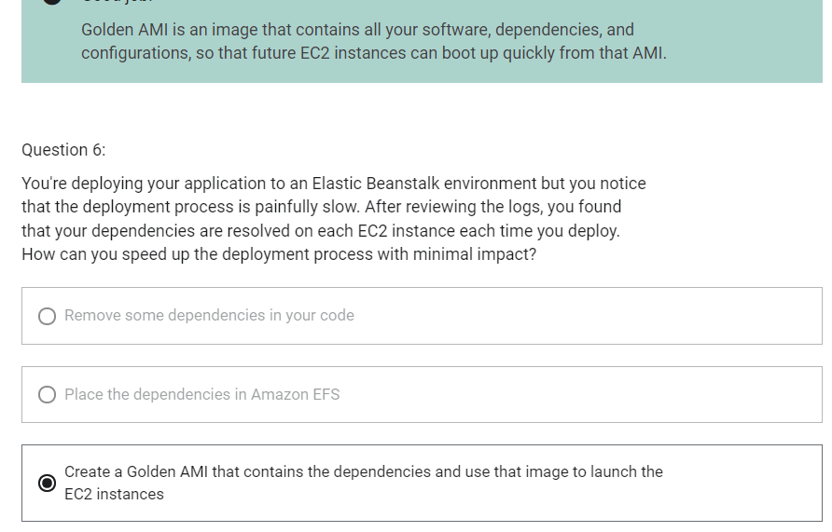

Amazon S3

1. “infinitely scaling” storage
2. Objects are stored in bucket
3. Buckets must have a globally unique name
4. Buckets are defined at regional level
5. Naming convention
   1. No uppercase
   2. No underscore
   3. 3-63 characters long
   4. Not an IP
   5. Must start with lowercase letter or number
6. Objects consist of:
   1. Key
      1. Key is the full path. Key is composed of prefix + object_name
      2. S3://my-bucket/my_file.txt
      3. S3://my-bucket/my_folder1/another_folder/my_file.txt
   2. Value
      1. content of the body
      2. Max object size is 5 TB (5000 GB)
      3. If uploading more than 5 GB, must use “multi-part upload”
   3. Version ID (if versioning is enabled)
   4. Tags
   5. Metadata

Amazon S3- Versioning

1. You can version your files in Amazon S3
2. It is enabled at the bucket level
3. Same key overwrite will increment the version: 1,2,3,…
4. It is the best practice to version your buckets
   1. Protect against unintended deletes
   2. Easy roll back to previous version
5. Any file that is not versioned prior to enabling versioning will have version “null”
6. Suspending versioning does not delete previous versions
7. When we delete a file, it is not deleted permanently, a delete marker is added on top.
8. To delete permanently, we need to delete both object and delete marker.

Amazon S3- Encryption

S3 Encryption for Objects

1. Encryption can be performed in object level or bucket level.
2. When default encryption is enabled in bucket level, encryption will be performed for every files uploaded into that bucket.
3. There are four methods of encrypting objects in S3
4. SSE-S3: encrypts S3 objects using keys handled and managed by AWS
5. SSE-KMS: leverage AWS Key Management Service to manage encryption keys
6. SSE-C: when you want to manage your own encryption keys
7. Client Side Encryption

SSE-S3

1. Encryption using keys handled and managed by Amazon S3
2. Object is encrypted server side
3. AES-256 encryption type
4. Must set header: “x-amz-server-side-encryption”: “AESS56”

SSE-KMS

1. Encryption using keys handled and managed by KMS
2. Object is encrypted server side
3. KMS Advantages
   1. User control
   2. Audit trail
4. Must set header: “x-amz-server-side-encryption”: “aws:kms”

SSE-C

1. Encryption using data leys fully managed by customer outside of KMS
2. Amazon S3 does not store the encryption key you provide
3. HTTPS must be used. HTTPS is mandatory for SSE-C.
4. Server-side encryption
5. Encryption key must be provided in HTTP headers, for every HTTP request made

Client Side Encryption

1. Client Library such as the Amazon S3 Encryption Client
2. Clients must encrypt data themselves before sending to S3
3. Clients must decrypt themselves when retrieving from S3
4. Customer fully manages the keys and encryption cycle

Encryption in transit (SSL/TLS)

1. Amazon S3 exposes
   1. HTTP endpoint: non encrypted
   2. HTTPS endpoint: encryption in flight
2. Encryption in flight is also called SSL/TLS

S3 Security

1. User based
   1. IAM policies- which API calls should be allowed for a specific user from IAM console
2. Resource based
   1. Bucket Policies- bucket wide rules from the S3 console, allows cross account
   2. Object Access Control list- finer grain
   3. Bucket Access Control list
3. An IAM principal can access an S3 object if
   1. The user IAM permissions allow it OR the resource policy allows it
   2. AND there is no explicit DENY

S3 Bucket Policies

1. JSON based policies
   1. Resources: buckets and objects
   2. Actions: Set of API to Allow or Deny
   3. Effect: Allow/Deny
   4. Principal: the account or user to apply policy to
2. Used for
   1. Grant public access to the bucket
   2. Force objects to be encrypted at upload
   3. Grant access to another account (Cross Account)

Block Public Access

1. Block Public Access in will block public Access to the bucket
2. It can be set on account level

S3 Security- Other

1. Networking
   1. Supports VPC Endpoint
2. Logging and Audit
   1. S3 Access Logs can be stored in other S3 bucket
   2. API calls can be logged in AWS CloudTrail
3. User Security
   1. MFA Delete- MFA can be required in versioned buckets to delete objects
   2. Pre-signed URLs- URLs that are valid only for a limited time

S3 Websites

1. S3 can host static websites and have them accessible on the www
2. The website URL will be
   1. <bucket-name>.s3-website-<AWS-region>.amazonaws.com
   2. <bucket-name>.s3-website.<AWS-region>.amazonaws.com
3. If you get a 403 (Forbidden) error, make sure the bucket policy allows public reads

S3 CORS

CORS (Cross Region Resource Sharing)

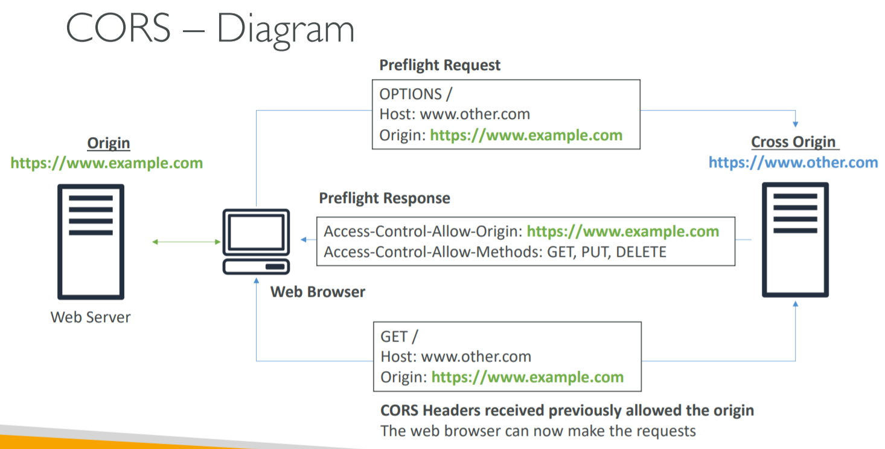

1. An origin is a protocol, domain and port
   1. E.g. <https://www.example.com> (implied port is 443 for HTTPS, 80 for HTTP)
2. CORS means Cross Origin Resource Sharing
3. Web Browser based mechanism to allow requests to other origins while visiting the main origin
4. Same origin: <http://example.com/app1> and <http://example.com/app2>
5. Different origins: <http://www.example.com> and <http://other.example.com>
6. The request won’t be fulfilled unless the other origin allows for the request, using CORS Headers (ex: Access- Control-Allow-Origin)

S3 CORS

1. If website_1 needs to access resource on website_2 through a web browser, then, website_2 needs to have CORS setting to allow request to be done otherwise the web-browser is going to block it.
2. If a client does a cross-origin request on our S3 bucket, we need to enable correct CORS headers
3. You can allow for a specific origin or for * (all origins)
4. CORS header should be defined in cross origin bucket not in first origin bucket

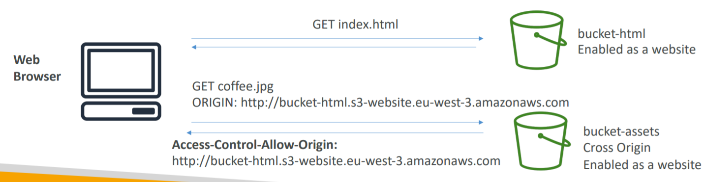

Amazon S3- Consistency Model

1. After a
   1. Successful write of a new object (new PUT)
   2. Or an overwrite or delete of an existing object (overwrite PUT or DELETE)
2. Any
   1. Subsequent read request immediately receives the latest version of the object (read after write consistency)
   2. Subsequent list request immediately reflects changes (list consistency)
3. Available at no additional cost, without any performance impact

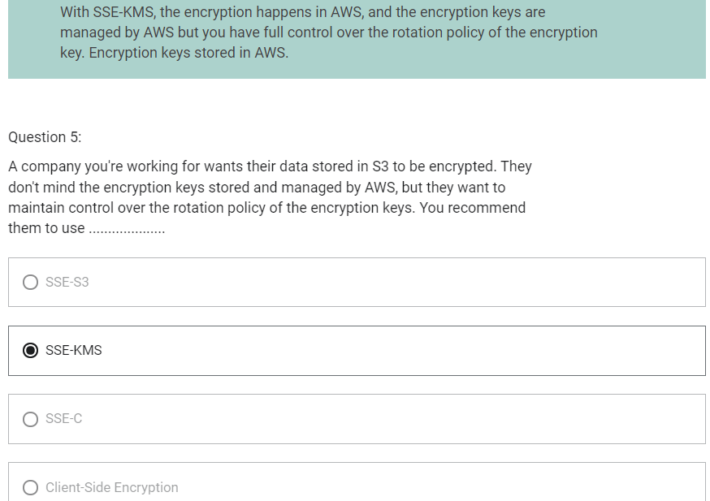

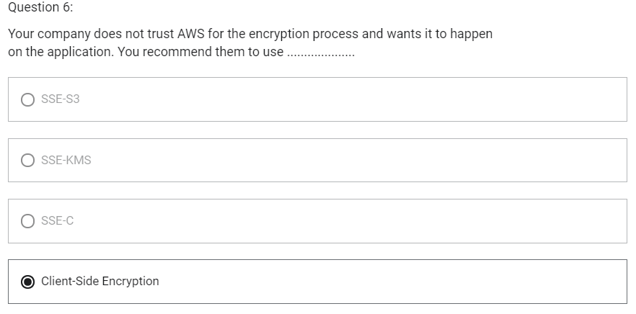

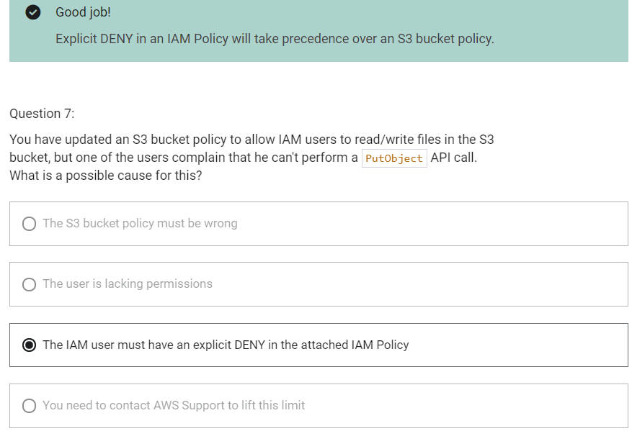

Policy Simulator

1. It helps us to test, understand and troubleshoot IAM policies that are attached to users, groups, roles or resources

EC2 Instance Metadata

1. Metadata = Info about EC2 instance
2. Userdata = launch script of the EC2 instance
3. It allows AWS EC2 instance to “learn about themselves” without using an IAM Role for that purpose
4. The URL is <http://169.254.169.254/latest/meta-data>
5. You can retrieve the IAM Role name from the metadata, but you cannot retrieve the IAM Policy

AWS SDK

1. Software Development Kit
2. Used to perform actions on AWS directly from your application code
3. Official SDKs are
   1. Java
   2. .NET
   3. Node.js
   4. PHP
   5. Python
   6. Go
   7. Ruby
   8. C++
4. We have to use AWS SDK when coding against AWS Services
5. AWS CLI uses Python SDK
6. If you do not specify of configure a default region, then us-east-1 will be chosen by default

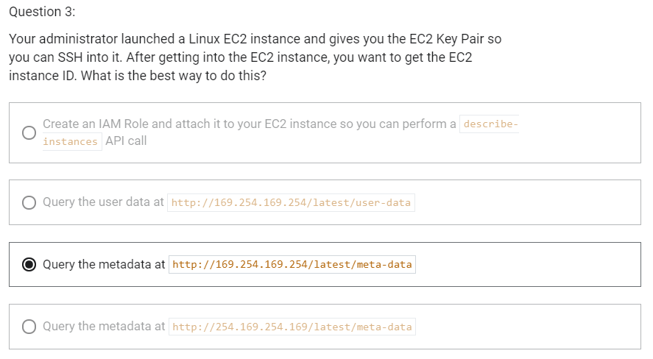

S3 MFA Delete

1. MFA forces user to generate a code on a device before doing important operations on S3
2. To use MFA-Delete, enable versioning on S3 bucket
3. You will need MFA to
   1. Permanently delete an object version
   2. Suspend versioning on the bucket
4. You won’t need MFA for
   1. Enabling versioning
   2. Listing deleted versions
5. Only the bucket owner (root account) (not even admin) can enable/disable MFA-Delete
6. MFA-Delete currently can only be enabled using CLI

S3 Default Encryption

S3 Default Encryption vs Bucket Policies

1. We can “force encryption” by using bucket policy and refuse any API call to PUT an S3 object without encryption headers.
2. Another way is to use the “default encryption” option in S3. If unencrypted object is uploaded into bucket, it will be encrypted using default encryption option. If the object is already encrypted, it will not be re-encrypted.
3. Note: Bucket Policies are evaluated before “default encryption”
4. If we need to force encryption mechanism of SSE-S3, you need to use bucket policy.
5. If the requirement is we need to encrypt every single object being encrypted into bucket, then we should use “Default Encryption”.
6. “Default Encryption” will not apply same encryption mechanism to all files. It is just making sure that if an object is uploaded in unencrypted manner, then it will automatically be encrypted using “default encryption” mechanism.

S3 Access Logs

1. For audit purpose, you may want to log all access to S3 buckets
2. Any request made to S3, from any account, authorized or denied, will be logged into another S3 bucket.
3. That data can be analyzed using data analysis tools or Amazon Athena
4. By enabling server access logging, S3 console will automatically update your bucket access control list (ACL) to include access to the S3 log delivery group.

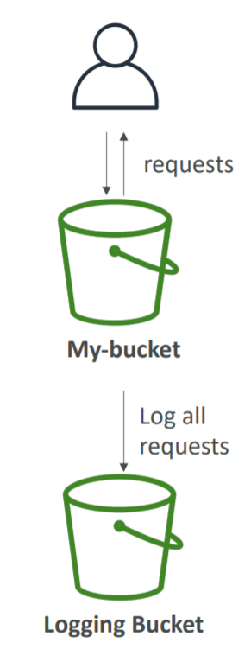

S3 Access Logs: Warning

1. Do not set your logging bucket to be the monitored bucket
2. It will create a logging loop and your bucket will grow in size exponentially

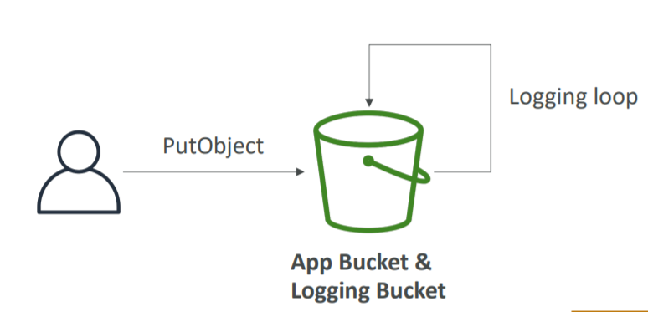

S3 Replication (CRR and SRR)

1. Replicate data between two objects asynchronously
2. Must enable versioning in both source and destination
3. Types of S3 Replication are
   1. Same Region Replication (SRR)
   2. Cross Region Replication (CRR)
4. Buckets can be in different accounts
5. Copying is asynchronous
6. Must give proper IAM permissions to S3
7. Use case for SRR
   1. Log aggregation
   2. Live replication between production and test accounts
8. Use case for CRR
   1. Compliance
   2. Lower latency access
   3. Replication across accounts
9. After activating replication, only new objects are replicated (not retroactive)
10. For delete operations
    1. Can replicate delete markers from source to target (optional setting-> Delete Marker Replication)
    2. Deletions with a version ID are not replicated (to avoid malicious deletes)
11. There is no chaining of replication
    1. If bucket 1 has replication into bucket 2, which has replication into bucket 3
    2. Then objects created in bucket 1 are not replicated to bucket 3

S3 pre-signed URLs

1. Can generate pre-signed URLs using SDK or CLI
   1. For downloads (easy, can use CLI)
   2. For uploads (harder, must use SDK)
2. Valid for a default of 3600 seconds, can change timeout with –expires-in [TIME_BY_SECONDS] argument
3. Users given a pre-signed URL inherit the permissions of the person who generated the URL for GET/PUT
4. Examples
   1. Allows only logged-on users to download a premium video on your S3 bucket
   2. Allow an ever changing list of users to download files by generating URLs dynamically
   3. Allow temporarily a user to upload a file to a precise location in our bucket

S3 Storage Classes

1. Amazon S3 Standard- General Purpose
2. Amazon S3 Standard- Infrequent Access (IA)
3. Amazon S3 One Zone Infrequent Access
4. Amazon S3 Intelligent Tiering
5. Amazon Glacier
6. Amazon Glacier Deep Archive
7. S3 Standard

* General purpose storage
* Data is stored across multiple availability zones
* Recommended for
  + Data that are frequently accessed
* Durability of 99.999999999%
* Availability of 99.99%

1. S3 Intelligent Tiering

* Automatically moves your data to most cost-effective storage class
* Automatic cost savings
* Data is stored across multiple availability zones
* Recommended for
  + Data with unknown or changing access pattern like new app or data lake
* Durability of 99.999999999%
* Availability of 99.9%

1. S3 Standard- Infrequent Access

* Data is accessed less frequently but requires rapid access (millisecond access)
* Cheaper than S3 Standard
* Data is stored across multiple availability zones
* Recommended for
  + Data which is not frequently accessed but requires rapid access (millisecond access)
* Durability of 99.999999999%
* Availability of 99.9%

1. S3 One Zone- Infrequent Access

* Data is accessed less frequently but requires rapid access (millisecond access)
* Costs 20% less than S3 Standard Infrequent Access
* Data is stored in single availability zone
* Data can be lost
* Recommended for
  + Data which is not frequently accessed but requires rapid access (millisecond access)
  + Availability and Durability is not so essential
  + Used for storing secondary backup copies of on-premises data
* Durability of 99.999999999%
* Availability of 99.5%

1. S3 Glacier

* Cold Storage for archival data
* Data Retrieval takes longer time
* 3 retrieval options:
  + Expedited 1-5 min
  + Standard 3-5 hours
  + Bulk 5-12 hours
* Data is stored in multiple availability zones
* Recommended for
  + Storage of archival data
* Durability of 99.999999999%
* Each item in Glacier is not called Object. It is called Archive. Each archive can be a file of upto 40 TB.
* Archives are not store in Bucket. They are stored in Vaults.
* Minimum storage duration of 90 days

1. S3 Glacier Deep Archive

* Like S3 Glacier but longer access time
* 2 retrieval options:
  + Standard 12 hours
  + Bulk 48 hours
* Cheapest of all S3 options
* Data is stored in multiple availability zones
* Recommended for
  + Long-term archival data which is accessed once or twice a year
  + Retaining data for regulatory compliance requirement
* Durability of 99.999999999%
* Minimum storage duration of 180 days

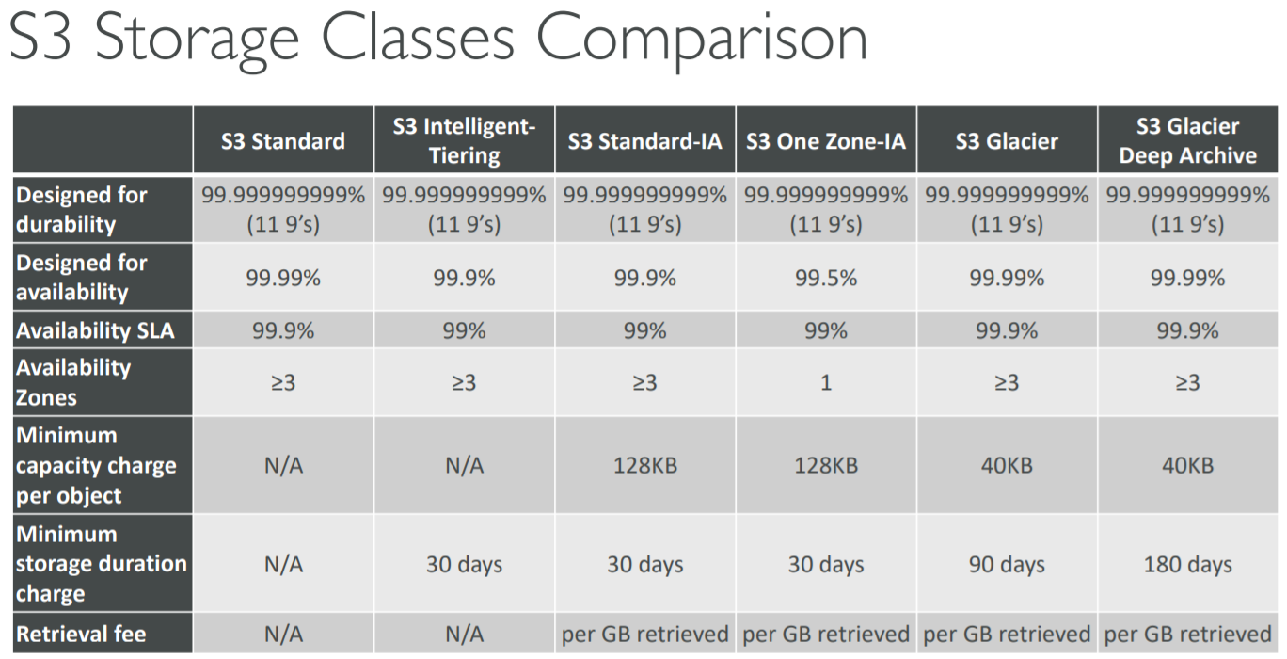

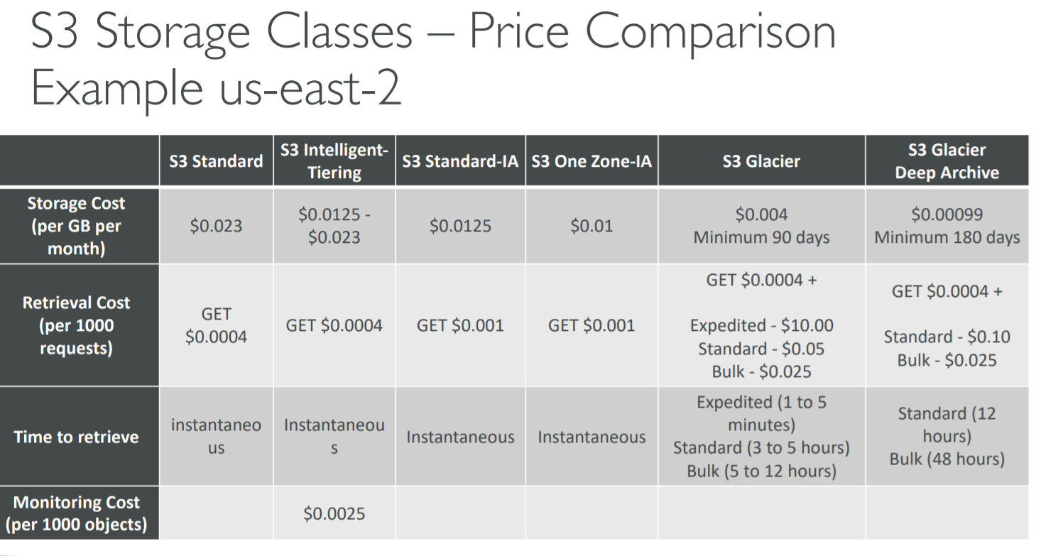

S3 Lifecycle Rules

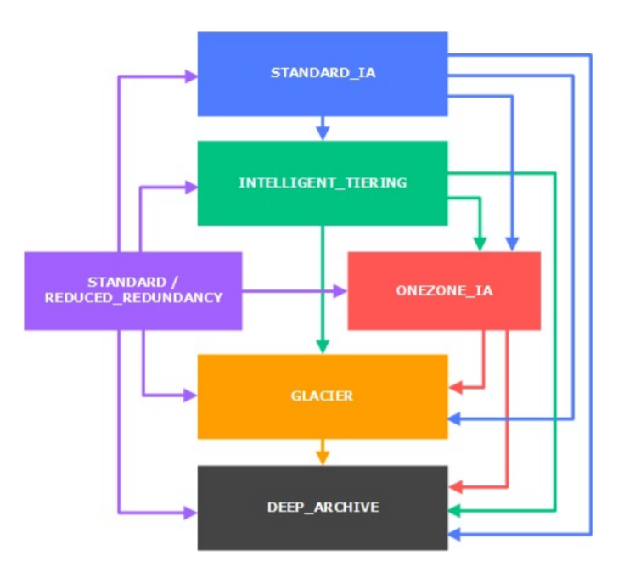

1. Moving objects between storage classes
2. You can transition objects between storage classes
3. For infrequently accessed objects, move them to STANDARD_IA
4. For archive objects, you don’t need in real-time, GLACIER or DEEP_ARCHIVE
5. Moving objects can be automated using a lifecycle configuration

S3 Lifecycle Rules

1. Transition actions
   1. It defines when objects are transitioned to another storage class
      1. Move objects to Standard IA class 60 days after creation
      2. Move to Glacier for archiving after 6 months
2. Expiration actions
   1. Configure objects to expire (delete) after some time
      1. Access log files can be set to delete after a 365 days
      2. Can be used to delete old versions of files (if versioning is enabled)
      3. Can be used to delete incomplete multi-part uploads
3. Rules can be created for a certain prefix (ex- s3://mybucket/mp3/*)
4. Rules can be created for certain objects tags (ex- Department: Finance)

S3 Lifecycle Scenarios

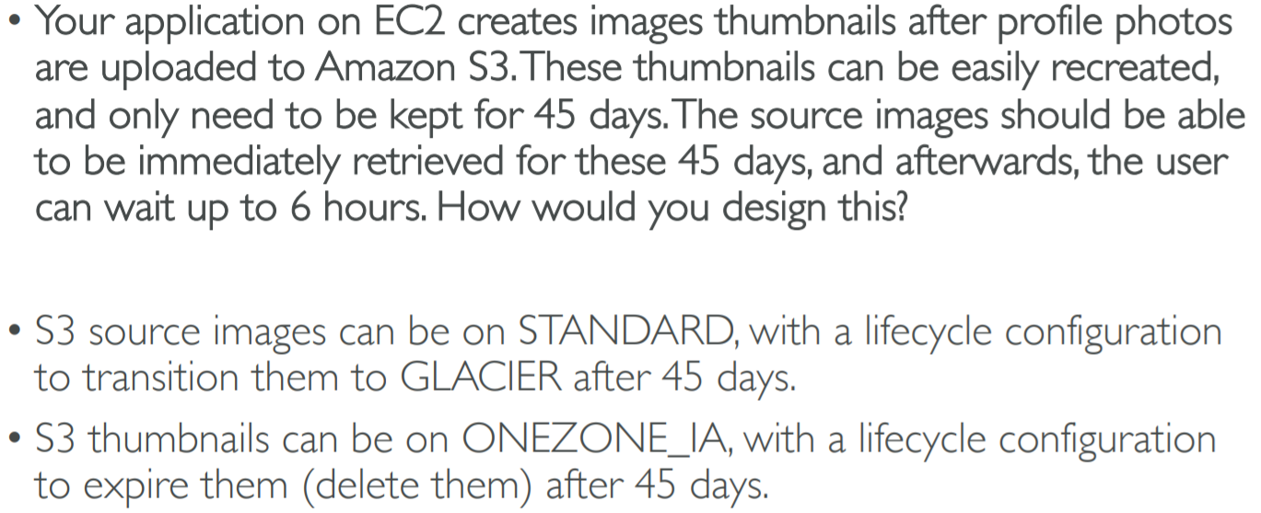

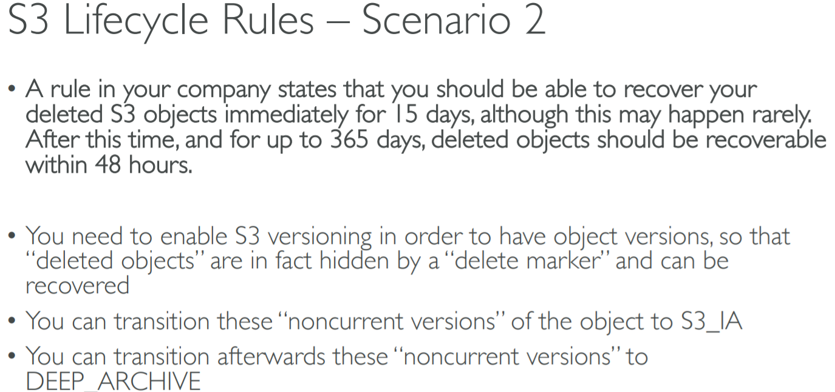

S3 Analytics- Storage Class Analysis

1. You can setup S3 Analytics to determine when to transition objects from Standard to Standard_IA
2. Does not work for ONEZONE_IA or GLACIER
3. Report is updated daily
4. Takes about 24hrs to 48hrs to first start
5. Good first step to put together Lifecycle Rules (or improve them)

S3- Baseline Performance

1. Amazon S3 automatically scale to high request rates, latency 100-200 ms
2. Your application can achieve at least 3,500 PUT/COPY/POST/DELETE and 5,500 GET/HEAD requests per second per prefix in a bucket
3. There are no limits to the number of prefixes in a bucket
4. Example (object_path=> prefix)
   1. Bucket/folder1/sub1/file => /folder1/sub1
   2. Bucket/folder1/sub2/file => /folder1/sub2
   3. Bucket/1/file => /1/
   4. Bucket/2/file => /2/
5. If you spread reads across all four prefixes evenly, you can achieve 22,000 requests per second for GET and HEAD

S3- KMS Limitation

1. If you use SSE-KMS, you may be impacted by the KMS limits
2. When you upload, it calls the GenerateDataKey KMS API
3. When you download, it calls the Decrypt KMS API
4. Count towards the KMS quota per second (5500, 10000, 30000 req/s based on region)
5. You can request a quota increase using the Service Quotas Console

S3 Performance

1. Multi-Part upload

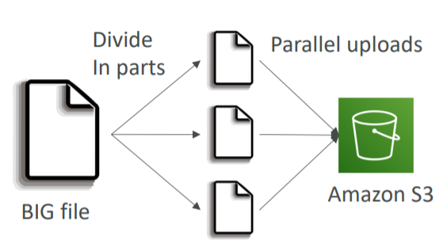

* 1. Recommended for files >100MB
  2. Must use for files>5GB
  3. Can help parallelize uploads (speed up transfer)

1. S3 Transfer Acceleration

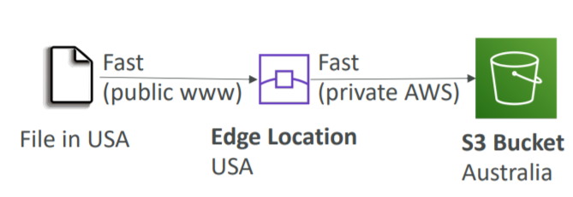

* 1. Increase transfer speed by transferring file to an AWS edge location which will forward the data to the S3 bucket in the target region
  2. Compatible with multi-part upload

S3 Performance- S3 Byte-Range Fetches

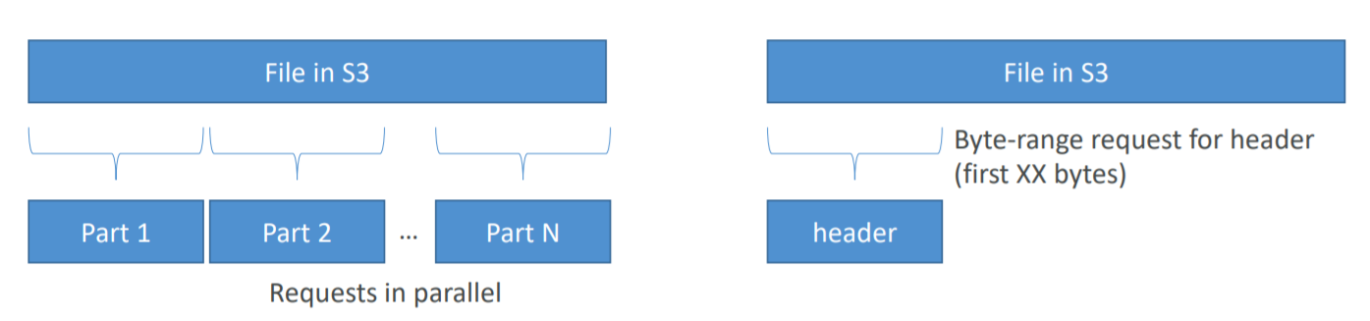

1. Parallelize GETs by requesting specific byte ranges
2. Better resilience in case of failures
3. Can be used to retrieve only partial data (for example the head of a file)

S3 Select and Glacier Select

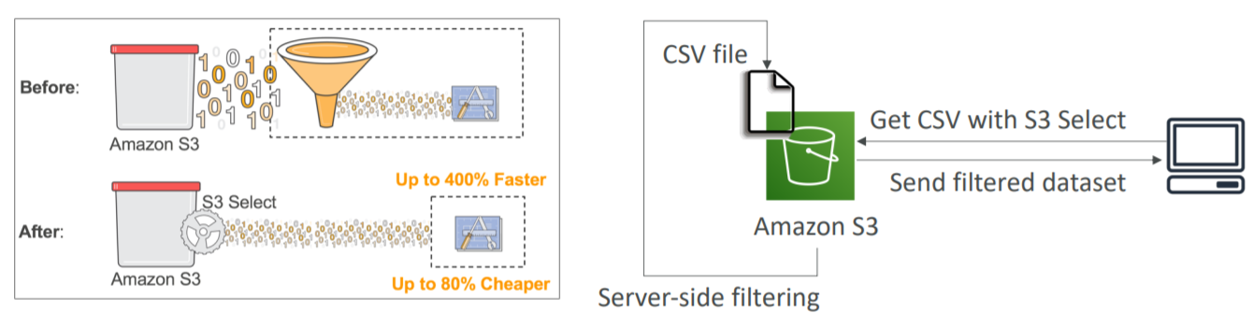

1. Retrieve less data using SQL by performing server-side filtering
2. Can filter by rows and columns (simple SQL statements)
3. Less network transfer, less CPU cost client-side

S3 Event Notifications

1. Some events happen in S3 bucket which may be ObjectCreated, ObjectRemoved, ObjectRestored, Replication
2. You want to react to all these events happening
3. This is possible through S3 Event Notification
4. Object name filtering is possible (*.jpg)
5. Use case
   1. Generate thumbnails of images uploaded to S3
6. Possible targets are
   1. SNS
   2. SQS
   3. Lambda function
7. Can create as many “S3 events” as desired
8. S3 event notifications typically deliver events in seconds but can sometimes take a minute or longer
9. If you want to make sure that every single event notification is delivered, then you need to enable versioning
10. If two writes are made to a single non-versioned object at the same time, it is possible that only a single event notification will be sent
11. If you want to ensure that an event notification is sent for every successful write, you can enable versioning on your bucket.

S3 Requester Pays

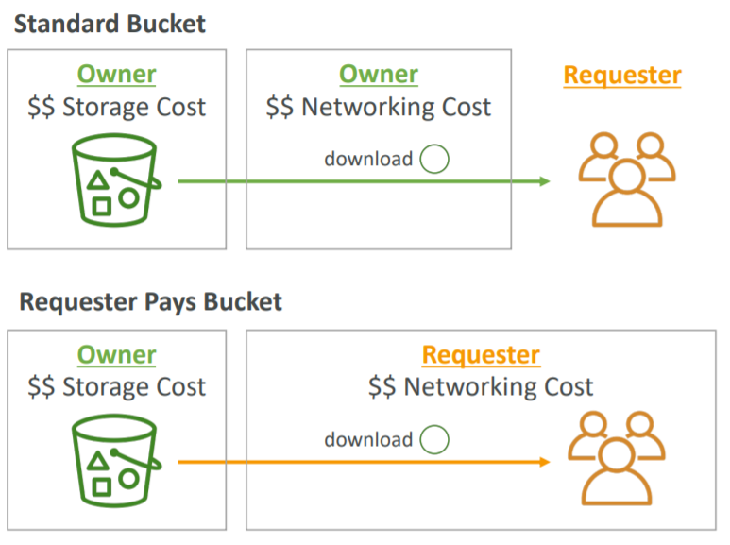

1. In general, bucket owner pay for all Amazon S3 storage and data transfer costs associated with their bucket
2. With Requester Pays buckets, the requester instead of the bucket owner pays the cost of the request and the data download from the bucket
3. Helpful when you want to share large datasets with other accounts
4. The requester must be authenticated (cannot be anonymous)

Amazon Athena

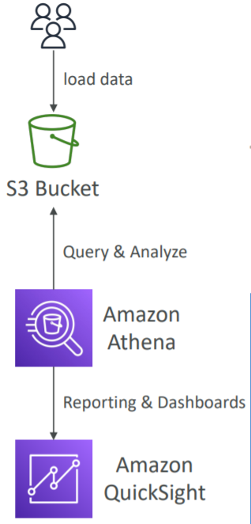

1. Analyze data in S3 using serverless SQL
2. Serverless query service to perform analytics against S3 objects
3. Uses standard SQL language to query the files
4. Supports CSV, JSON, ORC, Avro and Parquet (built on Presto)
5. Pricing: $5 per TB of data scanned
6. Use compressed or columnar data for cost-savings (less scan)
7. Use cases
   1. Building intelligence
   2. Analytics
   3. Reporting
   4. Analyze and query VPC Flow Logs, ELB Logs, CloudTrail trails, etc

Glacier Vault Lock

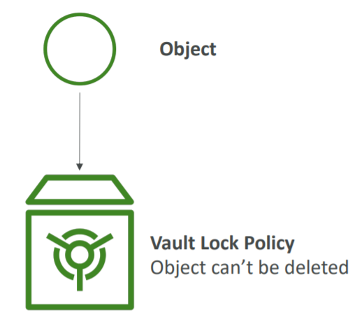

1. Adopt a WORM (Write Once Read Many) model
2. Lock the policy for future edits (can no longer be changed)
3. Helpful for compliance and data retention
4. The object is sent to Glacier and we can create a Vault Lock Policy specifying object cannot be deleted and the policy itself also cannot be deleted

S3 Object Lock

1. Versioning must be enabled
2. Adopt a WORM (Write Once Read Many) model
3. Block an object version deletion for a specified amount of time
4. Object retention
   1. Retention Period: specifies a fixed period
   2. Legal Hold: same protection, no expiry date
5. Modes
   1. Governance Mode: Users cannot overwrite or delete an object version or alter its lock settings unless they have special permissions
   2. Compliance Mode: a protected object version cannot be overwritten or deleted by any user, including the root user in your AWS account. When an object is locked in compliance mode, its retention mode can’t be changed and its retention period cannot be shortened

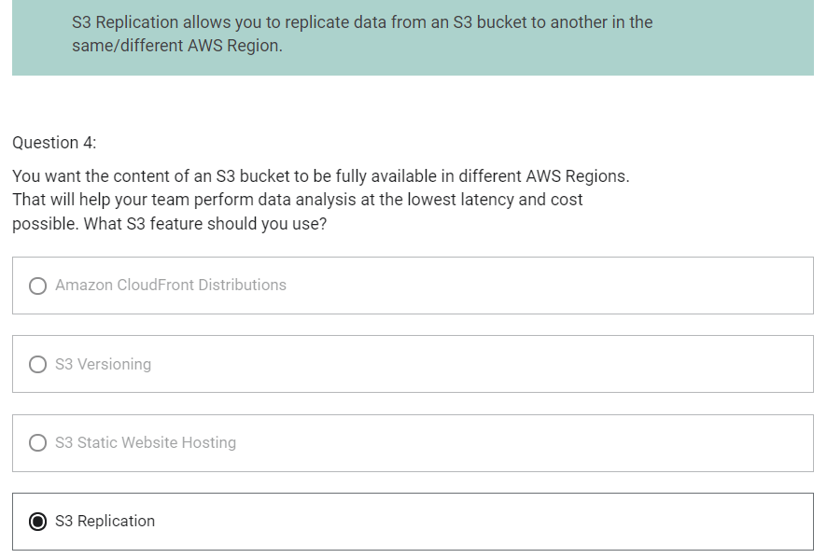

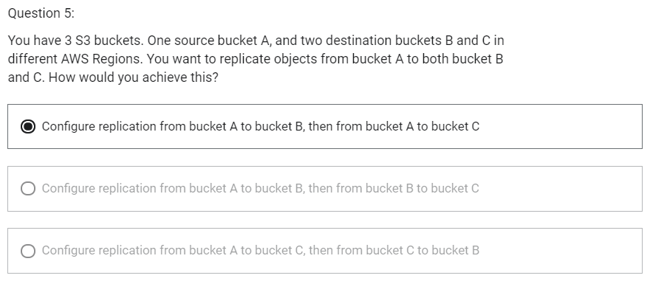

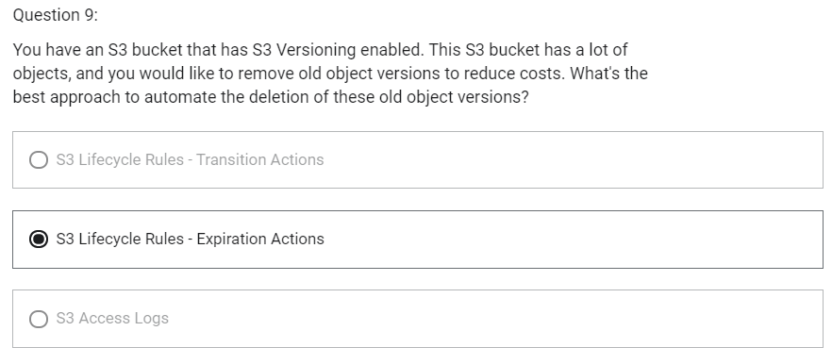

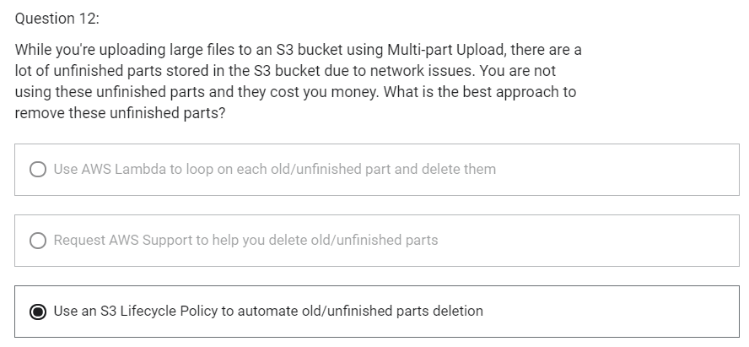

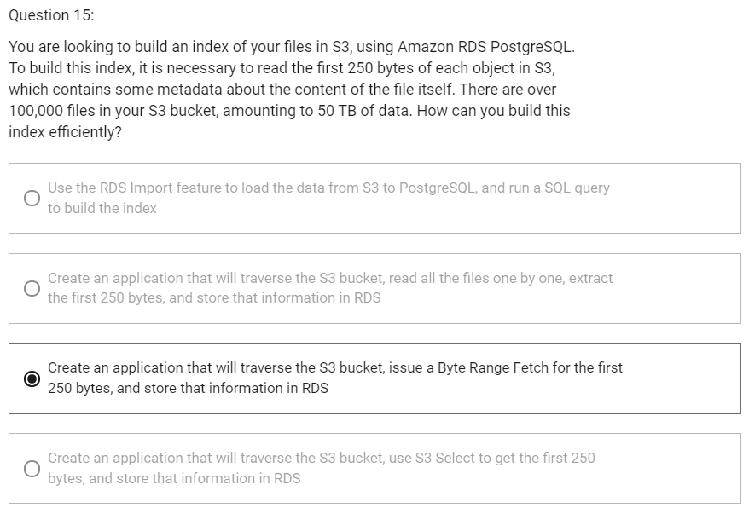

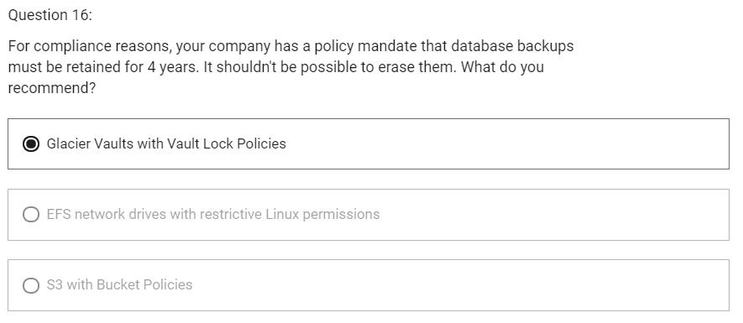

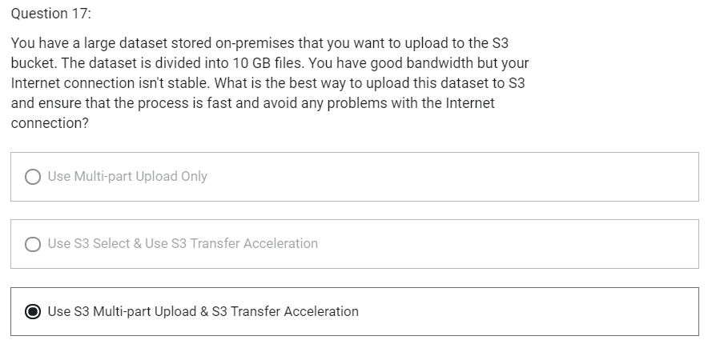

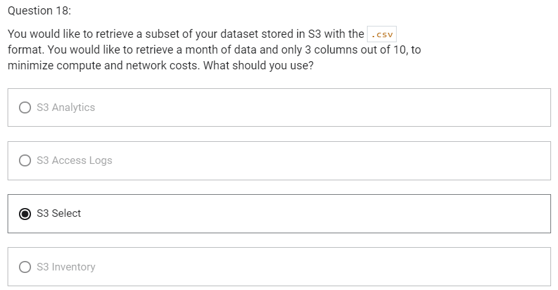

AWS CloudFront

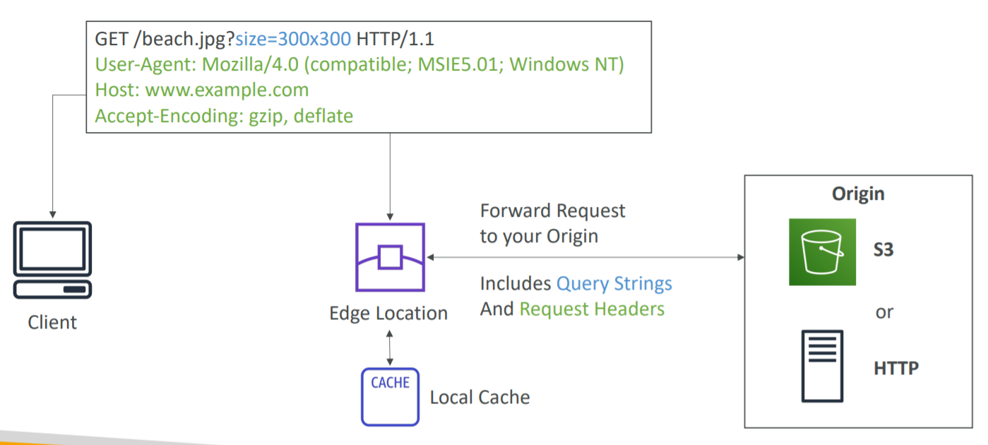

1. Content Delivery Network (CDN)
2. Improves read performance
3. Content is cached at the edge
4. DDoS protection
5. Integration with Shield, AWS WAF
6. Can expose external HTTPS and can talk to internal HTTPS backends

CloudFront- Origins

1. S3 bucket
   1. For distributing files and caching them at the edge
   2. Enhanced security with CloudFront Origin Access Identity (OAI)
   3. CloudFront can be used as an ingress (to upload files to S3)
2. Custom Origin (HTTP)
   1. Application Load Balancer
   2. EC1 Instance
   3. S3 website
   4. Any HTTP backend you want

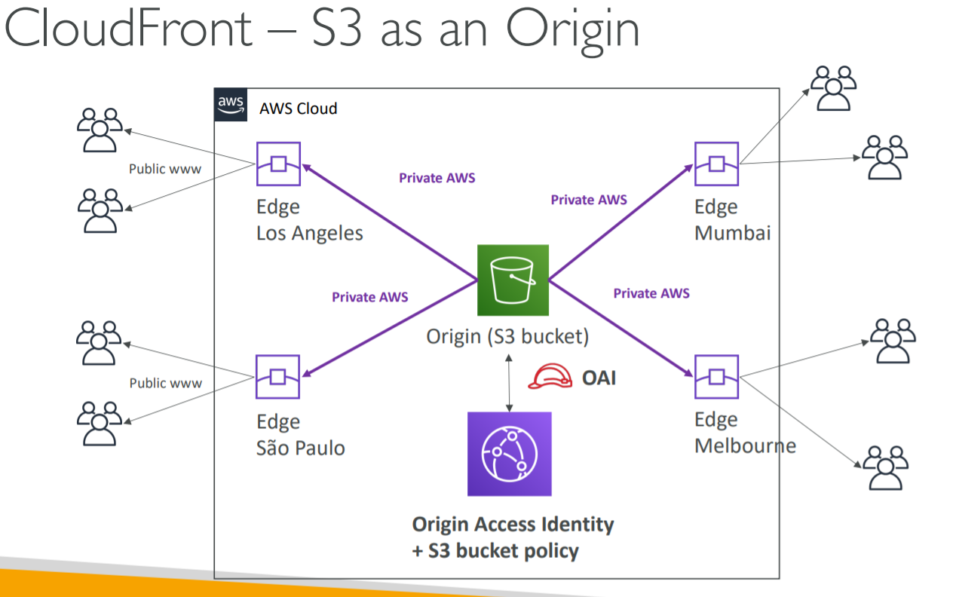

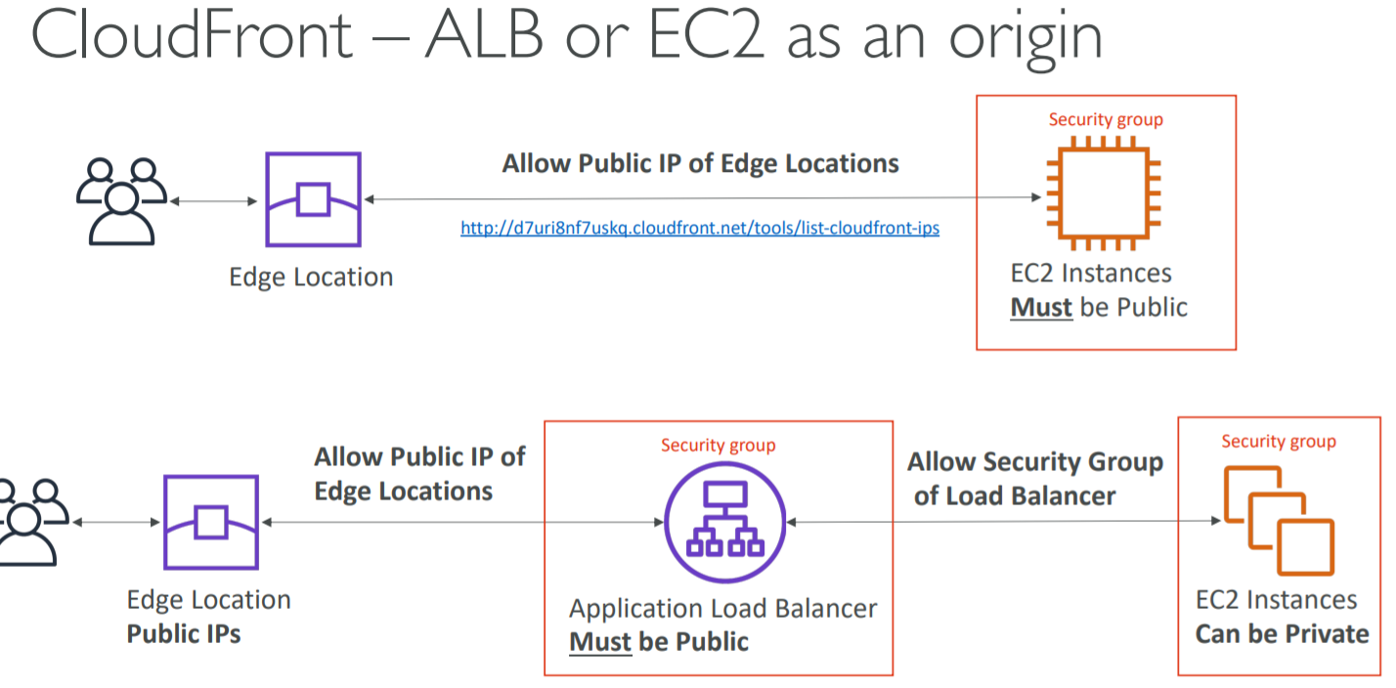

CloudFront- Geo Restriction

1. You can restrict who can access your distribution
   1. Whitelist
      1. Allow your users to access your content only if they are in one of the countries on a list of approved countries
   2. Blacklist
      1. Prevent your users from accessing your content if they are in one of the countries on a blacklist of banned countries
2. The “country” is determined using a 3rd party Geo-IP database
3. Use Case
   1. Copyright Laws to control access to content

CloudFront vs S3 Cross Region Replication

1. CloudFront
   1. Uses Global Edge Network
   2. Files are cached for a TTL (maybe a day)
   3. Great for static content that must be available everywhere
2. S3 Cross Region Replication
   1. Must be setup for each region you want replication to happen
   2. Files are updated in near real-time
   3. Read only
   4. Great for dynamic content that needs to be available at low-latency in few regions

CloudFront Signed URL/Signed Cookies

1. Suppose you have a CloudFront distribution and you want to make it private and you want to give access to people i.e. You want to distribute paid shared content to premium users over the world
2. We can use CloudFront Signed URL/ Cookie
3. First of all, when we create a URL/Cookie, we need to attach a policy with
   1. Includes URL expiration
   2. Includes IP ranges to access the data from
   3. Trusted signers (which AWS accounts can create signed URLs)
4. How long should the URL be valid for?
   1. Shared content (movie, music): make it short (a few minutes)
   2. Private content (private to the user): you can make it last for years
5. Signed URL-> access to individual files (one signed URL per file)
6. Signed Cookie-> access to multiple files (one signed cookie for many files)

CloudFront Signed URL vs S3 Pre-signed URL

CloudFront Signed URL

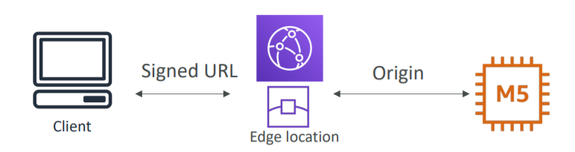

1. Allows access to a path, no matter the origin
2. Account wide key-pair, only the root can manage it
3. Can filter by IP, Path, date, expiration
4. Can leverage caching features

S3 Pre-Signed URL

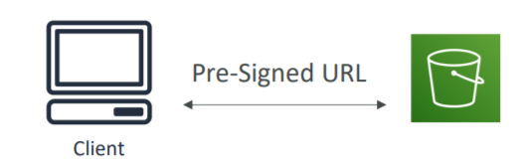

1. Issue a request as the person who pre-signed the URL
2. Uses the IAM key of the signing IAM principal
3. Limited lifetime

CloudFront – Pricing

1. CloudFront Edge Locations are all around the world
2. The cost of data out per edge location varies
3. You can reduce the number of edge locations for cost reduction
4. Three price classes are
   1. Price Class All: all regions- best performance
   2. Price Class 200: most regions, but excludes the most expensive regions
   3. Price Class 100: only the least expensive regions

CloudFront- Multiple Origin

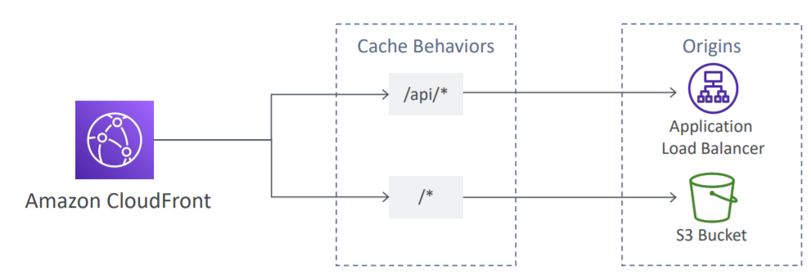

1. To route to different kind of origins based on the content type
2. Based on path pattern
   1. /images/*
   2. /api/*
   3. /*

CloudFront- Origin Groups

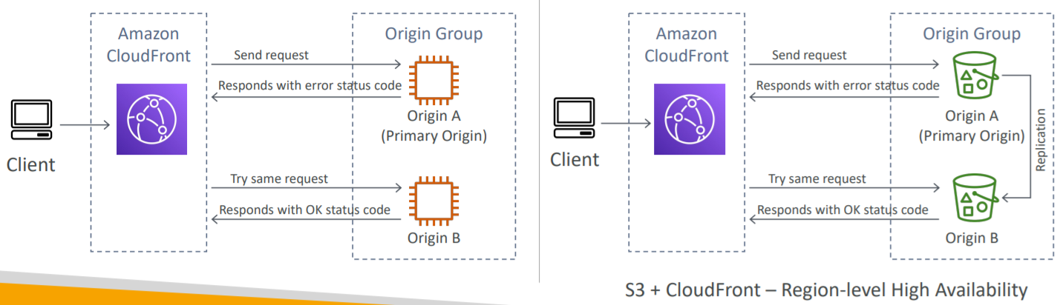

1. To increase high-availability and do failover
2. Origin Group- one primary and one secondary origin
3. If the primary origin fails, the second one is used
4. S3+CloudFront -> Region-level High Availability

CloudFront- Field Level Encryption

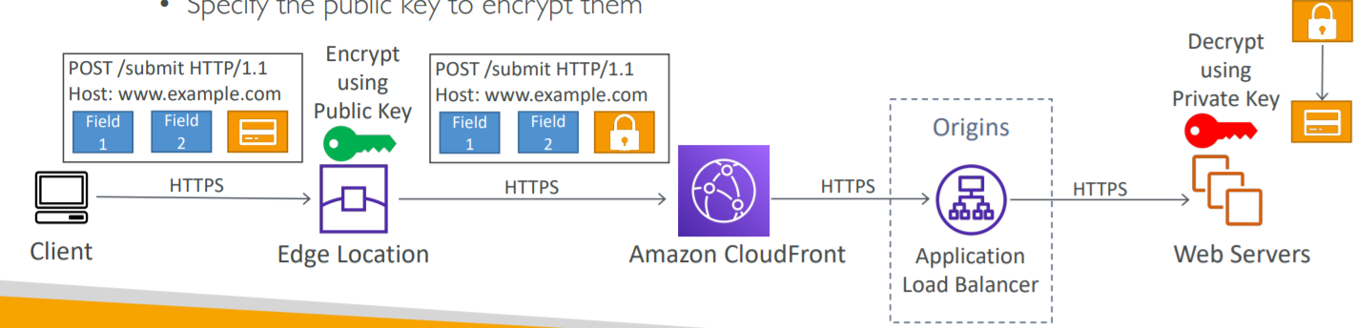

1. Protect user sensitive information through application stack
2. Adds an additional layer of security along the HTTPS
3. Sensitive information encrypted at the edge close to user
4. Uses asymmetric encryption
5. Usage
   1. Specify set of fields in POST requests that you want to be encrypted (up to 10 fields)
   2. Specify the public key to encrypt them

Unicast IP vs Anycast IP

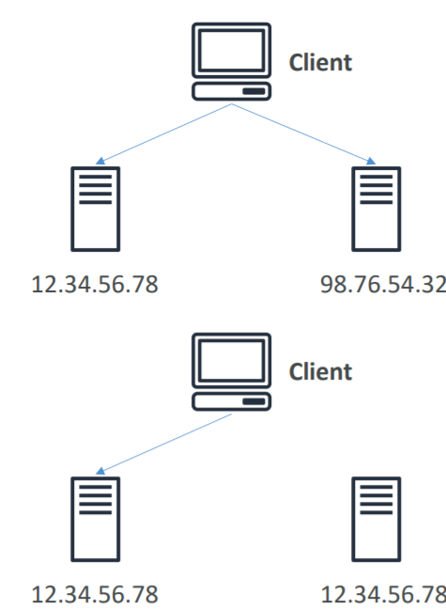

1. Unicast IP
   1. One server holds one IP address
2. Anycast IP
   1. All servers hold the same IP address and the client is routed to the nearest one

AWS Global Accelerator

1. Works with Elastic IP, EC2 instances, ALB, NLB, private or public

AWS Global Accelerator vs CloudFront

1. They both use the AWS global network and its edge locations around the world
2. Both services integrate with AWS Shield for DDoS protection

CloudFront

1. Improves performance for both cacheable content (such as images and videos)
2. Dynamic content (such as API acceleration and dynamic site delivery)
3. Content is served at the edge

Global Accelerator

1. Improves performance for a wide range of applications over TCP or UDP
2. Proxying packets at the edge to applications running in one or more AWS Regions
3. Good fit for non-HTTP use cases, such as gaming (UDP), IoT (MQTT), or Voice over IP
4. Good for HTTP use cases that require static IP addresses
5. Good for HTTP use cases that require deterministic, fast regional failover

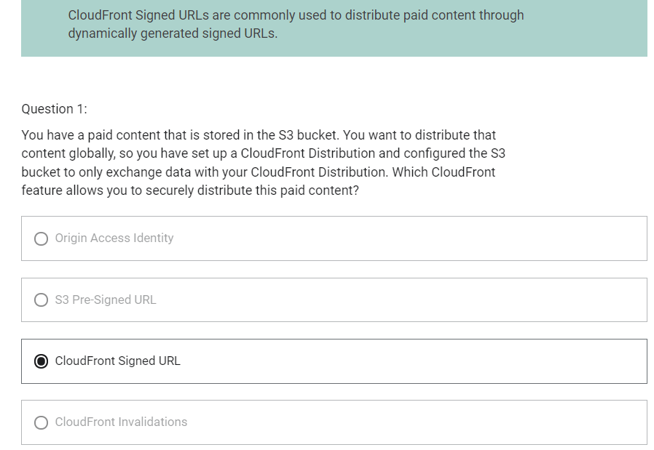

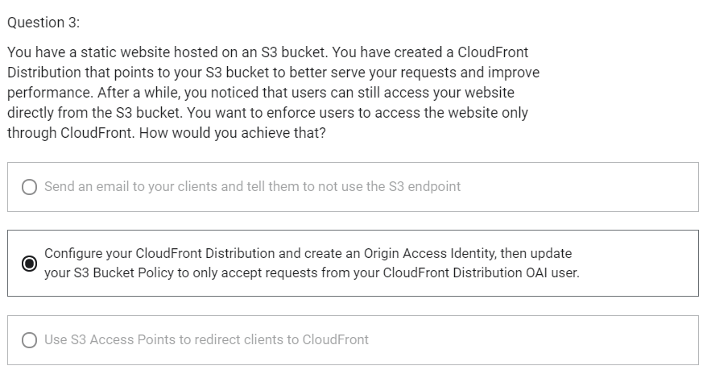

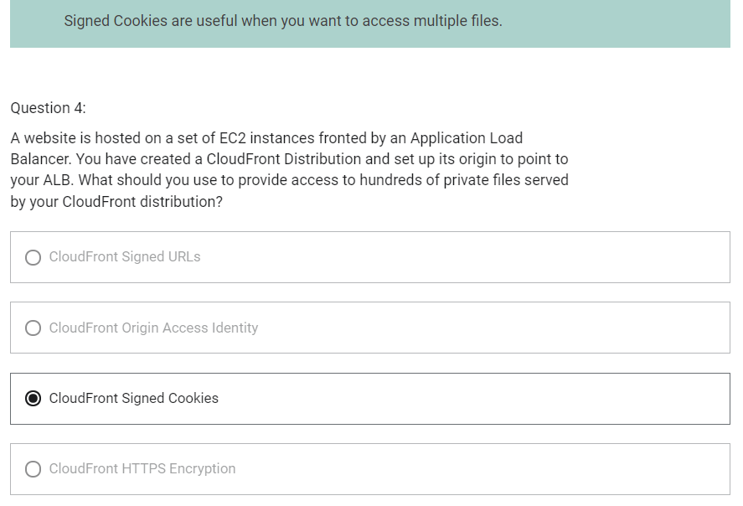

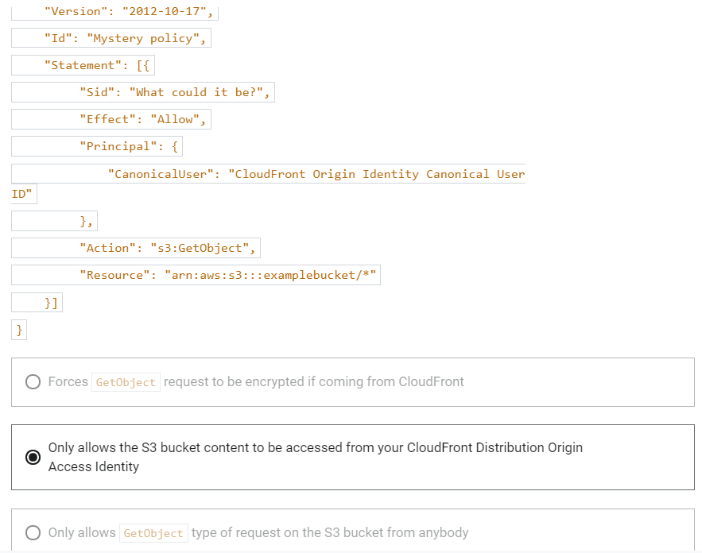

Snow Family

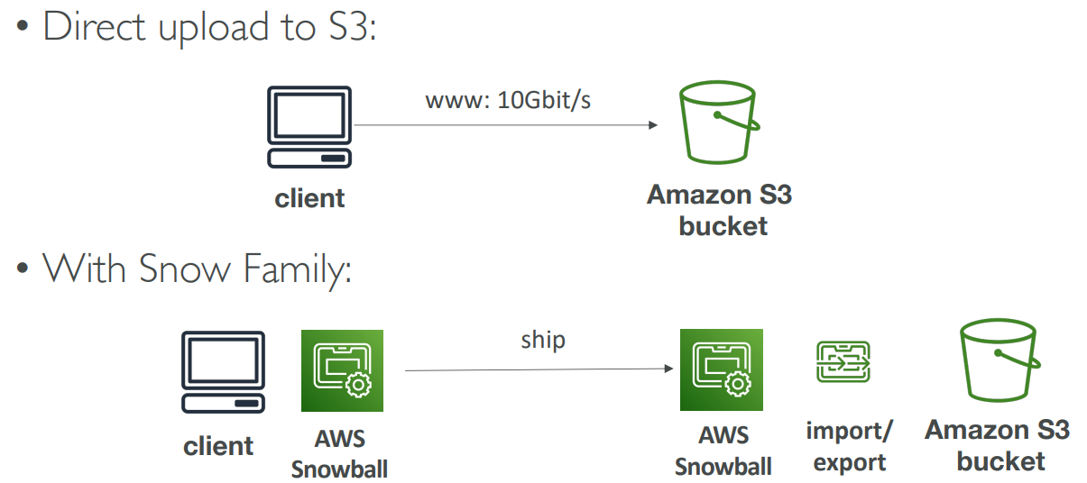

1. Offline devices to perform data migrations
2. If it takes more than a week to transfer over the network, use Snowball devices
3. Data is migrated through physical route not network route
4. Use cases
   1. Data Migration- Snowcone, Snowball Edge, Snowmobile
   2. Edge computing- Snowcone, Snowball Edge

Snowcone

1. Small, portable computing, anywhere, rugged and secure, withstand harsh environment
2. Used for edge computing, storage and data transfer
3. 8 TB of usable storage

Snowball Edge (for data transfers)

1. Physical data transport solution
2. Pay per data transfer job
3. Provide block storage and Amazon S3-compatible object storage
4. Snowball Edge comes in two flavours
   1. Snowball Edge Storage Optimized
      1. 80 TB of HDD capacity for block volume and S3 compatible object storage
   2. Snowball Edge Compute Optimized
      1. 42 TB of HDD capacity for block volume and S3 compatible object storage

Snowmobile

1. Transfer exabytes of data
2. Each snowmobile has 100 PB of capacity
3. High security: Temperature controlled, GOS, 24X7 video surveillance
4. Better than snowball if you transfer more than 10 PB

1 EB = 1,000 PB = 1,000,000 TB

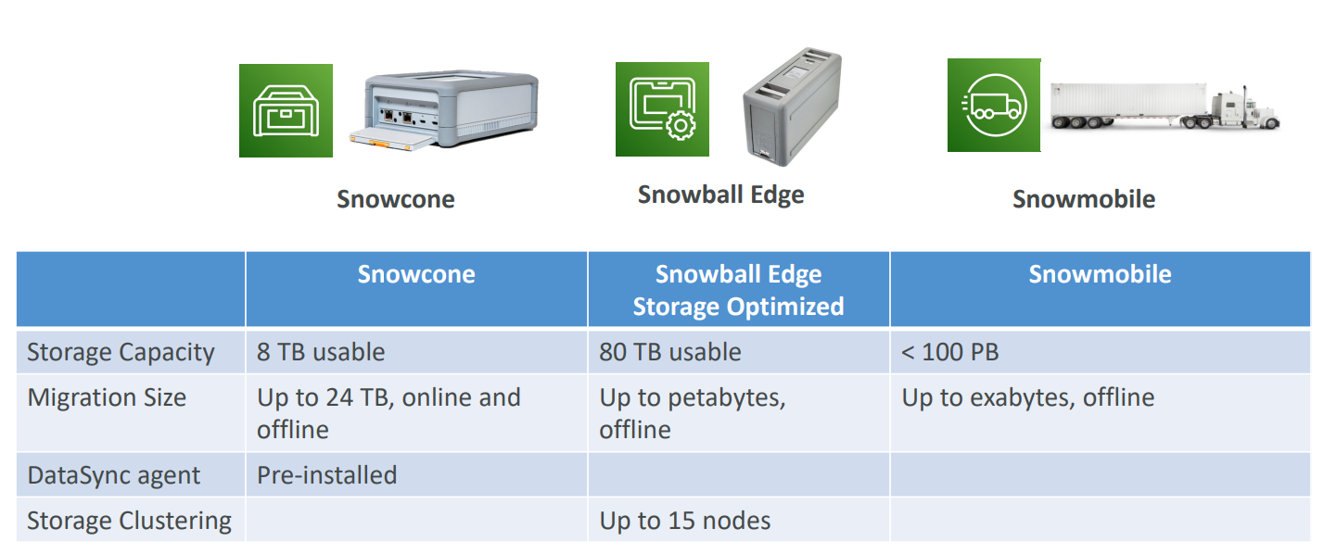

What is Edge Computing

1. Process data while it is being created on an edge location
   1. A truck on the road
   2. A ship on the sea
   3. A mining station underground
2. These locations may have
   1. Limited/ no Internet access
   2. Limited/ no easy access to computing power
3. We setup a Snowball Edge/ Snowcone device to do edge computing

Snow Family- Edge Computing

1. Snowcone (smaller)
   1. 2 CPUs
   2. 4 GB of memory
   3. Wired or wireless access
   4. USB-C power using a cord or optional battery
2. Snowball Edge- Compute Optimized
   1. 52 vCPUs
   2. 208 GiB of RAM
   3. Optional GPU (useful for video processing or machine learning)
   4. 42 TB usable storage
3. Snowball Edge- Storage Optimized
   1. Up to 40 vCPUs, 80 GiB of RAM
   2. Object storage clustering available
4. All of these can run EC2 instances and AWS lambda functions using AWS IoT Greengrass

AWS OpsHub

1. Historically, to use Snow Family devices, you needed a CLI (Command Line Interface tool)
2. Today, you can use AWS OpsHub (a software you install on your computer/laptop) that provides Graphical Interface to manage your Snow Family Devices.

Solution Architecture: Snowball into Glacier

1. Snowball cannot import to Glacier directly
2. You must use Amazon S3 first, in combination with an S3 lifecycle policy

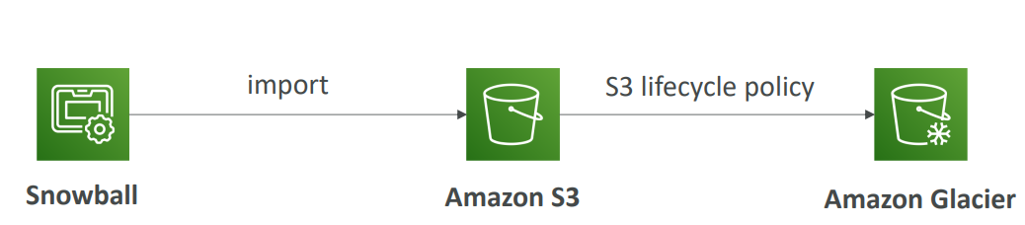

Amazon FSx

1. Fully managed service
2. Launch 3rd party high-performance file systems on AWS
3. FSx for Lustre
4. FSx for Windows File Server
5. FSx for NetApp ONTAP

Amazon FSx for Windows

1. FSx for Windows is a fully managed Windows file system share drive
2. Supports SMB protocol and Windows NTFS
3. Microsoft Active Directory integration, ACLs, user quotas
4. Built on SSD, scale up to 10s of GB/s, millions of IOPS, 100s PB of data
5. Can be accessed from your on-premise infrastructure
6. Can be configured to be Multi-AZ (high availability)
7. Data is backed up daily to S3

Amazon FSx for Lustre

1. Lustre is a type of parallel distributed file system, for large-scale computing
2. The name Lustre is derived from Linux and Cluster
3. Use case
   1. Machine learning
   2. High Performance Computing (HPC)
   3. Video processing
   4. Financial Modeling
   5. Electronic Design Automation
4. Scales up to 100s GB/s, millions of IOPS, sub-ms latencies
5. Seamless integration with S3
   1. Can “read S3” as a file system (through FSx)
   2. Can write the output of the computations back to S3(through FSx)
   3. Can be used from on-premises servers

FSx File System Deployment Options

1. Scratch File System
   1. Temporary storage
   2. Data is not replicated
   3. Use case
      1. Short term processing
      2. Optimize costs
2. Persistent File System
   1. Long term storage
   2. Data is replicated within same AZ
   3. Can replace failed files within minutes
   4. Use case
      1. Long term processing
      2. Sensitive data

AWS Storage Options

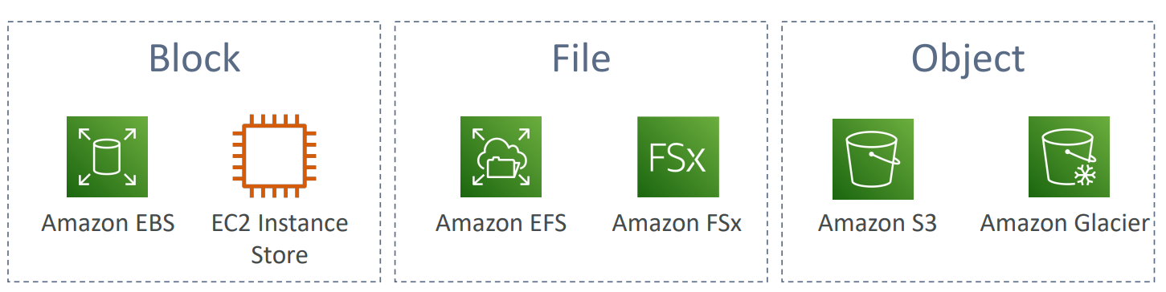

Storage Gateway

1. Bridge between on-premises data and cloud data in S3
2. Use case
   1. Disaster recovery
   2. Backup restore
   3. Tiered storage
3. 3 types of Storage Gateway
   1. File Gateway
   2. Volume Gateway
   3. Tape Gateway

File Gateway

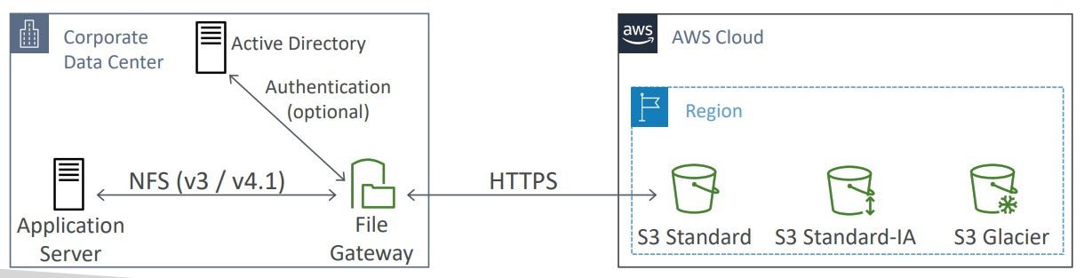

1. Configured S3 buckets are accessible using NFS and SMB protocol
2. Supports S3 Standard, S3 IA, S3 One Zone IA
3. Bucket access using IAM roles for each File Gateway
4. Most recently used data is cached in file gateway
5. Can be mounted on many servers
6. Integrated with Active Directory (AD) for user authentication

Volume Gateway

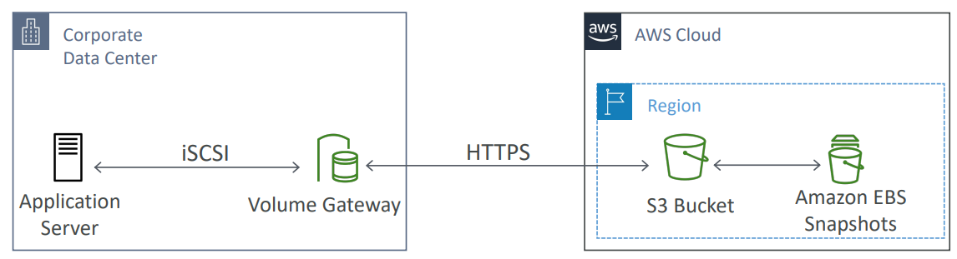

1. Block storage using iSCSI protocol backed by S3
2. Backed by EBS snapshots which can help restore on-premises volumes
3. Two types of Volume Gateway
   1. Cached Volumes: low latency access to most recent data
   2. Stored volumes: entire dataset is on premise, scheduled backups to S3

Tape Gateway

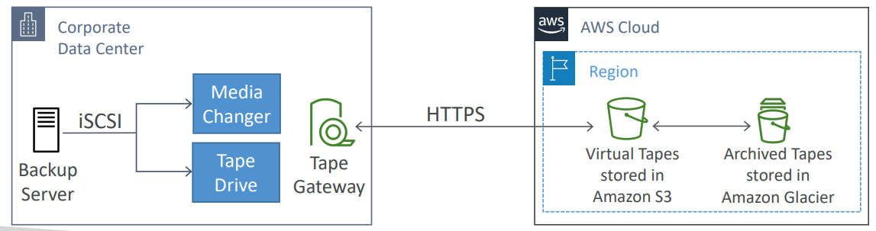

1. Some companies have backup processed using physical tapes
2. Virtual Tape Library (VTL) backed by Amazon S3 and Glacier
3. Back up data using existing tape-based processes (and iSCSI interface)
4. Works with leading backup software vendors

Storage Gateway- Hardware Appliance

1. Using Storage Gateway means you need on-premises virtualization
2. Otherwise, you can use a Storage Gateway Hardware Appliance
3. You can buy it on amazon.com
4. Works with File Gateway, Volume Gateway, Tape Gateway
5. Has the required CPU, memory, network, SSD cache resources
6. Helpful for daily NFS backups in small data centers

AWS Storage Gateway Summary

1. On premises data to the cloud-> Storage Gateway
2. File access / NFS- user auth with Active Directory-> File Gateway (backed by S3)
3. Volumes/ Block Storage/ iSCSI-> Volume gateway (backed by S3 with EBS snapshots)
4. VTL Tape Solution/ Backup with iSCSI-> Tape Gateway (backed by S3 and Glacier)
5. No on-premises virtualization-> Hardware Appliance

Amazon FSx File Gateway

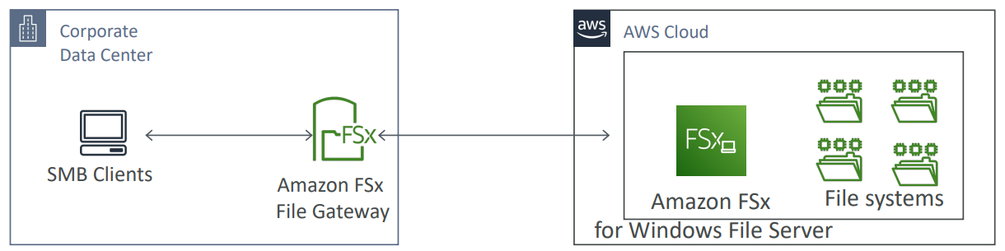

1. Native access to Amazon FSx for Windows File Server
2. Local cache for frequently accessed data
3. Windows native compatibility (SMB, NTFS, Active Directory,..)
4. Useful for group file shares and home directories

AWS Transfer Family

1. Fully managed service for file transfers into and out of Amazon S3 or Amazon EFS using FTP protocol
2. Supported protocols
   1. AWS Transfer for FTP (File Transfer Protocol (FTP))
   2. AWS Transfer for FTPS (File Transfer Protocol over SSL (FTTPS))
   3. AWS Transfer for SFTP (Secure File Transfer Protocol (SFTP))
3. Managed infrastructure, scalable, reliable, highly available (multi-AZ)
4. Pay per provisioned endpoint per point + data transfers in GB
5. Store and manage users credentials within the service
6. Integrate with existing authentication systems (Microsoft Active Directory, LDAP, Okta, Amazon Cognito, custom)
7. Usage
   1. Sharing files
   2. Sharing public datasets
   3. CRM
   4. ERP

Storage Comparison

1. S3- Object Storage
2. Glacier- Object Archival
3. EFS- Network File System for Linux, POSIX filesystem
4. FSx for Windows- Network File System for Windows servers
5. FSx for Lustre- High Performance Computing Linux file system
6. EBS volumes- Network storage for one EC2 instance at a time
7. Instance Storage- Physical storage for your EC2 instance (high IOPS)
8. Storage Gateway- File Gateway, Volume Gateway (cache and stored), Tape Gateway
9. Snowball/ Snowmobile- to move large amount of data to the cloud, physically
10. Database- for specific workloads, usually with indexing and querying